Chapter 1: Overview of the Project

1. Introduction

Every university student needs to be updated with his/her course related matters. Nowadays this work is tried to be done easily through internet. Thus teachers update the course materials and students obtain them with ease. Teachers open different groups for different courses using platforms like Facebook, Google, and Piazza. All students join the groups to stay updated about the related course. They need to monitor every group regularly to keep up-to-dated. After finishing the courses the groups become invalid. Again new groups are created for new courses and the process continues perpetually.

2. Organization Overview

3. Aim of the Project

Our goal is building an omnipresent, universally synchronized platform accessible to all students and teachers of a university.

4. Project Overview

* Log-in, log-out for both teacher and students: for distinct presence of a user in the system.
* Course material uploads by teachers and class representatives: easy access at any time from any place only with an internet connection.
* Course syllabus: Detailed overview of a syllabus at a glance.
* Course outline: Shortened outline of the slide
* Discussion forum: Common platform for problem solving and guidelines
* Notice board: important notices in necessary time
* Mailing system: Communication between teacher and student
* Notification system for individuals: Notification of important updates
* Class test and quiz syllabus, assignment and offline topic.
* Class test, online, offline, assignment, quiz marks.
* A special routine indicating scheduled class tests’, assignments’ or off-lines’ deadline.
* Sessional subgroups.
* Giving off-line setting up deadline and submission with automatic prevention of submission after deadline.
* Archive all course material after course ends. Previous archives will be available to current students. (E.g. CSE-307 archive of 10 batch, 09 batch and so on will be available to 11 batch when they take the course.)
* Warning system to the students with lower attendance.

5. Motivation of the Project

5.1 Students’ Benefit

* Only one account to maintain in whole university life.
* Gets everything needed in one place in order.
* Lure of time killer sites diminished.
* No headache of finding groups to join.
* No need to go from door to door to know about class test syllabus or assignment topic.
* No more searching for marks.
* Easy off-line submission.
* Can see the next class test, quiz, assignment and offline time in a special routine, so manage his time accordingly.
* Easy to know what has been taught from the course outline in case of being unable to attend any class.
* Nice way to discuss about problems and solutions with his/her classmates and teacher through discussion forum.

5.2 Teachers’ Benefit

* No need to create new group in every term.
* Can see other teachers’ previously scheduled class test time and available slots to schedule his/hers.
* Give notice in notice board (e.g. about rescheduling of class or class test).
* Upload course materials.
* Make and edit course outline easily.
* Publish exam marks.
* Video lecture can be published in case of necessity.
* Off-line can be given setting up its deadline. Where an automated system will stop any student from submitting off-lines after that deadline.

6. Report Overview

Chapter 2: Existing System Study and Scope Definition

1. Introduction

To develop a new system or to improve a current system we need to analyze the current system. All existing fault need to be listed. Then after prioritizing the faults, they should be rebuild.

2. System Analysis

2.1 Operating Mechanism

* 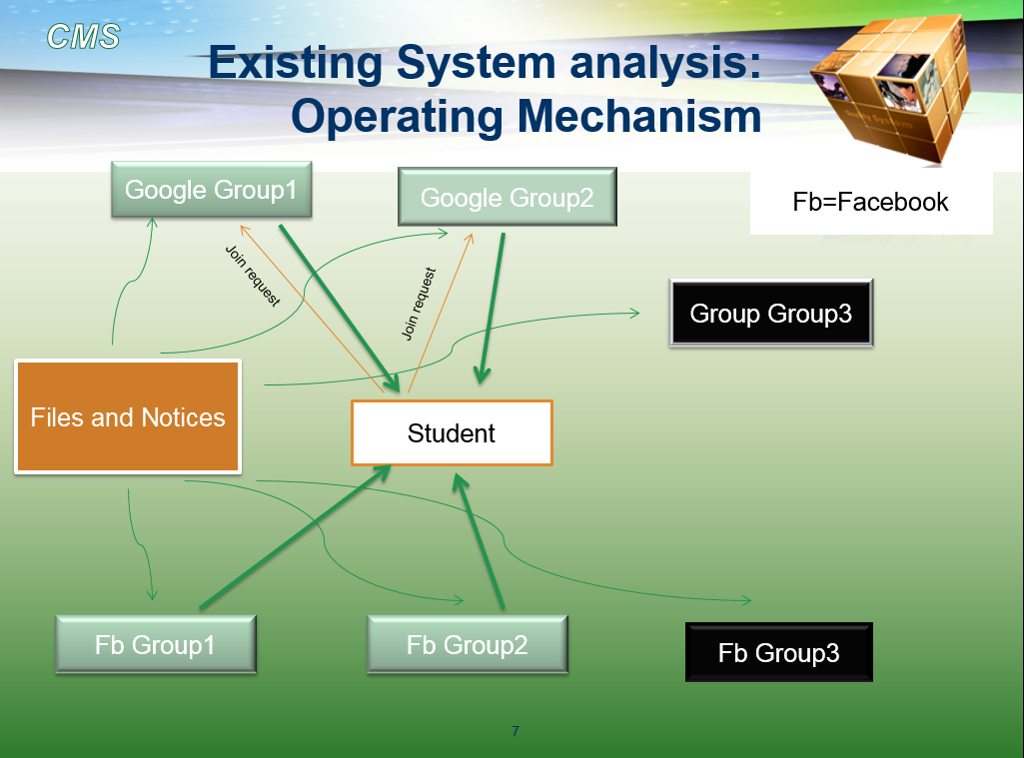Teachers open different groups for different courses using platforms like Facebook, Google, and Piazza.
* All students join the groups to stay updated about the related course.
* They need to monitor every group regularly to keep up-to-dated.
* After finishing the courses the groups become invalid.
* Again new groups are created for new courses and the process continues perpetually.

2.2 Problem and Automation Status

|  |  |
| --- | --- |
| **Problems of the current system** | **Automation status** |
| Different groups are opened in different platform specially Facebook. | Manual |
| Many teachers use some other platform (e.g. Google groups) to form groups and give updates. | Partially- automated |
| Other teachers give updates in class. | Manual |
| Students have to join several groups each term. | Manual |
| They have to check the groups regularly for updates. | Manual |
| Teaches have to discuss about CT schedule in classroom and knows his/her collogues CT schedule from discussion. | Manual |
| Class materials are manually ordered. | Manual |
| Discussion being difficult in lack of proper platform. | Partially- automated |
| Does not have archive system - archives are only managed on a personal level. | Manual |
| Inefficient process of keeping track of class tests’, online, off-line, assignment schedule. | Manual |
| Course material uploaded in an irregular basis. | Partially- automated |
| Taking attendance | manual |

3. Problem Analysis

|  |  |  |  |  |  |  |
| --- | --- | --- | --- | --- | --- | --- |
| **Project: Classroom *Management System*** | | | **Project Coordinator: *Johra Muhammad Moosa& Sajjadur Rahman*** | | | |
| **Created by: *Ifta Noor Mahmood*** | | | **Last updated by: Abdul Kawsar Tushar** | | | |
| **Date created: 22.01.2014** | | | **Date last updated: 26.01.2014** | | | |
| **Brief statement of problems opportunities and directives** | **Urgency** | **Visibility** | | **Benefit** | **Priority of Rank** | **Proposed Solution** |
| Numerous groups to maintain. | High | High | | ***** | 1 | Make a new system with all functionality of presently working groups. |
| No common platform. | High | High | | ***** | 1 | Make a common system for all |
| Course syllabus or outline are not in one place make it harder for a student to manage his/her study. | Medium | High | | **** | 2 | Make a course management system. |
| No easy way to make or update course outline for a teacher. | Medium | Medium | | *** | 2 | Make a course management system. |
| Teacher cannot give any emergency notice. He/she have to call CR’s, post in FB groups. | High | Medium | | ***** | 1 | Make a notification system. |
| Hard to keep track of any new updates for a student. | High | High | | **** | 1 | Make a notification system. |
| No common discussion forums | Low | Low | | *** | 3 | Make a discussion forum |
| A teacher does not know about his/her colleague's CT schedule. | Medium | Low | | *** | 3 | Make a dynamic routine. |
| Teacher cannot schedule his/her class test without discussion. | Low | Medium | | *** | 2 | Make a scheduler to manipulate the dynamic routine to schedule a test. |
| No archive system | Medium | Low | | **** | 2 | Make a archive system |
| Scattered study materials | High | High | | ***** | 1 | Make an automated ordering and classification system. |
| No common mailing system | Low | Low | | ** | 3 | Make an interuniversity mailing system. |
| No automated warning system | Low | Low | | ** | 3 | Make an automated warning system. |
| No exam management system | High | High | | ***** | 1 | Make an exam management system. |
| No sessional/project sub grouping system | Low | Low | | ** | 3 | Make sub grouping system |
| No online course offering system | Low | Low | | ** | 3 | Make a online course system |
| No online exam system | Low | Low | | ** | 3 | Make an online exam system |

4. Scope of Implementation

1. **Account management system:**
   * Log-in, log-out for both teacher and students.
   * Redirect students to an appropriate semester page.
   * Redirect teachers to course pages instructed by him/her.
2. **Course content management system:**
   * Course syllabus.
   * Course outline.
   * Course materials are uploaded by teachers and class representatives.
   * Archive all course material after course ends. Previous archives will be available to current students. (E.g. CSE-307 archive of 10 batch, 09 batch and so on will be available to 11 batch when they take the course.)
3. **Communication system:**
   * Discussion forum.
   * Mailing system.
4. **Notification & Warning system:**
   * Warn the students with lower attendance by teacher
   * Warn any member voiding group rules and regulation by admin.
   * Show new updates.
   * Notice board.
5. **Exam & class management system:**
   * Class test and quiz syllabus, assignment and offline topic.
   * Class test, online, offline, assignment, quiz marks
   * Schedule extra class..
   * Cancel extra class.
6. **Online Exam system:**
   * Taking and evaluation online exams.
7. **Online course system:**
   * Offering online courses.
8. **Interactive routine system:** 
   * Dynamic routine indicating scheduled class tests’, assignments’ or off-lines’ deadline.
   * Assign class test in a particular time by any course teacher.
9. **Sub grouping system:**
   * Sessional subgroups.
   * Project subgroups.

**We are going to working on:**

* + Account management system
  + Notification & warning system
  + Course content management system
  + Exam & class management system
  + Interactive routine system

**We are not going to working on:**

* + Online exam system
  + Online course system
  + Discussion forum(communication system)
  + Sessional subgroup system

Chapter 3: Requirement Analysis and feasibility study

1. **Fishbone Diagram**
   1. **Account Management System**
   2. **Course Content Management System**
   3. **Exam and Class Management System**
   4. **Notification and Warning System**

**1.5 Interactive Routine System**

**2. Feasibility Studies**

**2.1 Operational Feasibly**

* The development is usual web based development. Everything can be implemented using available technology. It is trivial that the technology we have today is very much feasible.
* We will be using oracle database. To maintain large amount of data oracle database is enough efficient.
* For file system, disk level memory is much cheaper today. So uploading file or keep the archive of previous files won’t be a problem.

**2.2 Cultural Feasibility**

* Today’s generation is much more accustomed to using internet. As our system is based on internet, it will be appreciated by the users.
* People want all information in a place. As our systems one of the main objective is to maintain all information in a place i.e. in a group, people will love to use it.

**2.3 Technical Feasibility**

* **Issue 1:** Is the proposed technology or solution is practical?
  + The proposal was to build a web based information system which is practical and easily implementable.
* **Issue 2:** Do we currently possess the necessary technology

|  |  |
| --- | --- |
| **Required Technology** | **Status** |
| Servers | Available |
| Personal Computers | Available |
| Internet | Available |
| Web based programming language | There are enormous web based programming languages |
| Data base | Oracle or SQL database can be made. |

* **Issue 3:** Do we possess the necessary technical expertise?
  + Yes, we do. Because we ourselves doing the work.
  1. **Schedule Feasibility**
* The estimated time for developing the whole system is about 3 month.
* The system is a need but it won’t be a problem
  1. **Economic Feasibility**
* **Cost:**
  + Development cost:
    - Manpower: 5/6 system developer and 1/2 personnel for data entry  
      Rough estimate: 500,000/-
    - Server rent: 4000/-
  + Operating cost:
    - Fixed costs:
      * Periodic checking and maintenance
      * server rent: 4000/year
    - Variable costs:
* **Bottom line:** 
  + Development cost and operating cost are relatively very low compared to a university’s annual budget.
  + BUET spends around 913.3 milion a year.  
    [Ref - <http://www.eduicon.com/News/Details/3011.html>]
* **Benefits:**

**Tangible benefit:**

* + As the project is not intended for business purposes it does not recur tangible benefits.
  + Some advertisement and sponsor offer can be obtained in future.

**Intangible benefit:**

* + Saving time of thousands of student. If the system saves 1 hour per day of each student then it will amount to a tremendous amount for all students over years of study.
  + No headache of getting used to with new platforms for each course each semester.
  + Saving labor for collecting different materials like previous years course materials etc.

Chapter 4: Proposed System Design

1. Introduction

In this chapter we will discuss about the design of our proposed system. Firstly the use-case diagram of the system. And then the dataflow diagram. We will also discuss the system design and process design.

2. Use Case Diagram

2.1 Actor Glossary

|  |  |  |
| --- | --- | --- |
| Actor | Short Key | Activity Scope |
| Admin |  | Approves account |
| Teacher |  | Upload course content, Schedule exam, Give Notice |
| Student |  | Download course content, Submit offline, View notification, View routine |
| Class Representative | CR | Upload course content |
| <<System>> Exam Management System | EMS | Invokes to send notification |
| <<System>> Course content Management System | CCMS | Invokes to send notification |

Account management system

Use-case Glossary:

|  |  |  |  |
| --- | --- | --- | --- |
| ID | UseCase name | Description | Participant actors and roles |
| 1.1 | Login | Providing access depending on accuracy of username and password | Teacher and student provide username and password |
| 1.2 | Logout | Logging out of the system | Teacher and student log out of the system |
| 1.3 | Open account | Creating a new account for access to certain courses | Teacher and student fill up a form, contents of the form  is forwarded to admin |
| 1.4 | Approve account | Approval of newly created account | Admin approves the account based on physical evidence |
| 1.5 | Show profile | Profile information is showed | Teacher and student can view their account information |
| 1.6 | Update profile | Profile information is updated | Teacher and student can update their profile; after  completion of update, Show profile is initiated |

**UseCase diagram**



**Login**

**Use case narrative**

|  |  |
| --- | --- |
| UseCase name | Define route and price |
| UseCase ID | 1.1 |
| Priority | High |
| Primary business actor | n/a |
| Primary system actor | Teacher, student |
| External server actor | Course Content Management System |
| External receiver actor | n/a |
| Description | Providing access depending on accuracy of username and password |
| Trigger | Teacher, student |

**Typical Course of Event**

|  |  |
| --- | --- |
| Actor Action | System Response |
| Teacher, student invokes Login | Requests for ID and password |
| Teacher, student give ID and password | 1. Verifies ID and password  2. If ID and password are correct, Course Content Management System is invoked |

**Documentation**

* Conclusion: concludes after invoking the CCMS
* Business rules
  + Show Course page under CCMS is only visible to appropriate receiver

Logout

**Use case narrative**

|  |  |
| --- | --- |
| UseCase name | Define route and price |
| UseCase ID | 1.2 |
| Priority | High |
| Primary business actor | n/a |
| Primary system actor | Teacher, student |
| External server actor | n/a |
| External receiver actor | n/a |
| Description | Logging out of the system |
| Trigger | Teacher, student |

**Typical Course of Event**

|  |  |
| --- | --- |
| Actor Action | System Response |
| Teacher, student invokes Logout | Lets the user log out of the system |

**Documentation**

* Conclusion: concludes after letting the user log out of the system

Open account

**Use case narrative**

|  |  |
| --- | --- |
| UseCase name | Define route and price |
| UseCase ID | 1.3 |
| Priority |  |
| Primary business actor | n/a |
| Primary system actor | Teacher, student |
| External server actor | Admin |
| External receiver actor | n/a |
| Description | Creating a new account for access to certain courses |
| Trigger | Teacher, student |

**Typical Course of Event**

|  |  |
| --- | --- |
| Actor Action | System Response |
| Teacher, student invokes Create account | Request information in a form about the user who is trying to create a new account |
| Teacher, student submits the form with information | The information is the form is sent to the Admin |

**Documentation**

* Conclusion: concludes after sending the form to the admin.
* Business rules
  + Information in the form is hidden expect for the eyes of the admin.

Approve account

**Use case narrative**

|  |  |
| --- | --- |
| UseCase name | Define route and price |
| UseCase ID | 1.4 |
| Priority | High |
| Primary business actor | Teacher, student |
| Primary system actor | Admin |
| External server actor | n/a |
| External receiver actor | n/a |
| Description | Approval of newly created account |
| Trigger | Admin |

**Documentation**

* Conclusion: Concludes after informing teacher/student of confirmation of approval.
* Business rules:
  + Only admin can approve accounts.

**Typical Course of Event**

|  |  |
| --- | --- |
| Actor Action | System Response |
| Admin invokes Approve account | Presents a list of forms waiting to be approved |
| Admin selects the accounts to be approved | Information is sent to respective teacher/student informing the news of approving |

Show Profile

**Use case narrative**

|  |  |
| --- | --- |
| UseCase name | Define route and price |
| UseCase ID | 1.5 |
| Priority | Medium |
| Primary business actor | n/a |
| Primary system actor | Teacher, student |
| External server actor | n/a |
| External receiver actor | n/a |
| Description | Profile information is showed |
| Trigger | Teacher, student |

**Typical Course of Event**

|  |  |
| --- | --- |
| Actor Action | System Response |
| Teacher, student invokes Show Profile | Shows the profile information of the respective profile |

**Documentation**

* Conclusion: concludes after showing teacher/student profile information of the respective profile.
* Business rules:
  + Only the respective teacher/student can see information of his/her account .

Update Profile

**Use case narrative**

|  |  |
| --- | --- |
| UseCase name | Define route and price |
| UseCase ID | 1.6 |
| Priority | Medium |
| Primary business actor | n/a |
| Primary system actor | Teacher, student |
| External server actor | n/a |
| External receiver actor | n/a |
| Description | Profile information is updated |
| Trigger | Teacher, student |

**Typical Course of Event**

|  |  |
| --- | --- |
| Actor Action | System Response |
| Teacher, student invokes Update Profile | Shows a list of items from the profile that can be updated/changed |
| Teacher, student selects and submits the information to be updated | 1. Information is updated in the main database 2. Show Profile is invoked |

**Documentation**

* Conclusion: concludes after Show Profile is invoked.
* Business rules: Only the respective teacher/student can update information of his/her account.

Course Content Management System

**Use case Glossary:**

|  |  |  |  |
| --- | --- | --- | --- |
| Use Case id | Use Case Name | Actors | Participant actor and roles |
| 2.1 | Show Course pages | Student, Teacher | Actor wants to see the course contents |
| 2.2 | File Upload | Course Teacher, CR, Admin | Course teacher/CR uploads course materials |
| 2.3 | File Download | Student, Teacher | Student downloads the uploaded course materials |
| 2.4 | Archiving | Admin, student, teacher | Admin archive the previous course contents & student & teacher can access |

**Use Case Diagram**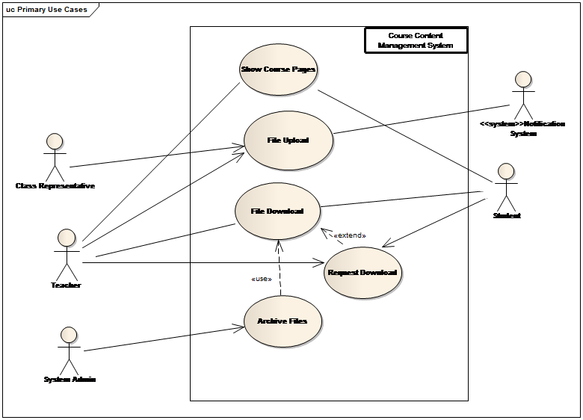

Show Course Pages

**Use Case Narrative**

|  |  |
| --- | --- |
| Use Case Name | Status and Route |
| Use Case Id | 2.1 |
| Priority | High |
| Initialization Actor | Teacher, Student |
| Receiver Actor | Student, Teacher |
| Trigger | login |

**Typical Course of events**

|  |  |
| --- | --- |
| Actor Action | System Response |
| Actors login into the system | System will identify the actor using login info and redirect him to his/her respective course pages |

**Documentation:**

**Initiation**: Process will start with the logging into the system

**Pre** **Condition**: Actor must be logged in with valid information

**Implementation** **Issue**: Proper GUI will be provided into the system for the actor to show the respective course pages.

File Upload

**Use Case Narrative**

|  |  |
| --- | --- |
| Use Case Name | Status and Route |
| Use Case Id | 2.2 |
| Priority | High |
| Initialization Actor | Teacher, Class Representative |
| Receiver Actor | Student |

**Typical Course of events**

|  |  |
| --- | --- |
| Actor Action | System Response |
| Teacher/CR uploads file | System will save the file in a specific location for the file and a notification will be initiated to the students who registered in the course |

**Documentation:**

**Initiation:** Process will start with the uploading of files by the teacher/CR

**Pre**-**Condition**: Actor must be logged in with his/her account in the system

**Post** **Condition**: System must inform the students through notification

**Implementation** **Issue**: Proper GUI and slots will be provided to upload the files.

File Download

**Use Case Narrative:**

|  |  |
| --- | --- |
| Use Case Name | Status and Route |
| Use Case Id | 2.3 |
| Priority | High |
| Initialization Actor | Student |
| Receiver Actor | Student |
| Trigger | Notification System |

**Typical Course of events:**

|  |  |
| --- | --- |
| Actor Action | System Response |
| Student wants to download files | System will allow the download process to start for those files that the student has access. |

**Documentation:**

**Initiation**: Process will start with the download request from the student

**Pre**-**Condition**: Actor must be logged in with his/her account in the system and must have access to the file

**Implementation** **Issue**: Proper GUI and a link will be provided in the webpage for the download process

Archive

**Use Case Narrative**

|  |  |
| --- | --- |
| Use Case Name | Status and Route |
| Use Case Id | 2.4 |
| Priority | High |
| Initialization Actor | Admin |
| Receiver Actor | Student ,Teacher |
| Trigger | End of each term |

**Typical Course of events:**

|  |  |
| --- | --- |
| Actor Action | System Response |
| After each term finishes the Admin of the system puts all the files from the previous term in a archived folder | System will store the files in a specific folder naming it according to the term and batch |
| Students/Teachers want to download archived files | System will redirect to 1.3 for download process |

**Documentation:**

**Initiation**: Process will start with the end of each term

**Post** **Condition**: Both teachers and students will be given access to the respective archived files

**Implementation** **Issue**: Proper GUI and server space will be provided to store all the files.

Exam and Class Management System

**Use case Glossary:**

|  |  |  |  |
| --- | --- | --- | --- |
| Use Case id | Use Case Name | Actors | Participant actor and roles |
| 3.1 | Cancel Exam/Class | Teachers , IRS, Notification Subsystem | Teacher decides to cancel exam or class , so routine is updated and notifies students |
| 3.2 | Schedule Class | Teachers, IRS | Teachers decides time for class from available time andIR is updated. |
| 3.3 | Schedule Exam | Teachers, Notification Subsystem, IRS | Teachers decides date for exam, notification goes to students and IR is updated. Can decide syllabus. |
| 3.4 | Giving Syllabus | Teachers, Notification Subsystem, IRS | Teachers decide syllabus, Students are notified of syllabus andIRupdated. |
| 3.5 | Exam Mark upload | Teachers , Notification Subsystem | Teachers upload marks , Students will be notified that marks are uploaded |
| 3.6 | Give and submit offline | Teachers, Notification Subsystem , Students , Time | Teachers give offline and sets deadline time, system notifies student and. After deadline no offline is taken |

**Use-case diagram**



Teacher

Cancel Exam / Class

**Use Case Narrative:**

|  |  |
| --- | --- |
| Use Case Name | Status and Route |
| Use Case Id | 3.1 |
| Priority | Medium |
| Initialization Actor | Teacher |
| Receiver Actor | Notification Subsystem , IRS |

**Typical Course of events:**

|  |  |
| --- | --- |
| Actor Action | System Response |
| Teachers will cancel schedule of exam or class | When exam or class is cancelled , then students will be notified through notification system , and also their IRS will be updated |

**Documentation:**

**Initiation**: Process will start with cancelling date of exam or class by teacher

**Pre**-**Condition**: Initiation must be done with an account with permission to cancel exam/class of that course, and it must exist class/exam in the system

**Post** **Condition**: System must inform the students through notification

**Implementation** **Issue**: Interacting with the notification subsystem and IRS.

Schedule Class

**Use Case Narrative:**

|  |  |
| --- | --- |
| Actor Action | System Response |
| Teachers will schedule a class when routine shows available time | When class is placed on a free time of routine, IRS will change. |

**Documentation:**

**Initiation**: Process will start with scheduling time of class by teacher

**Pre**-**Condition**: Initiation must be done with an account with permission to schedule class of that course, and corresponding time is free in IR

**Implementation** **Issue**: Interacting with IRS.

Scheduling Exam

**Use Case Narrative:**

|  |  |
| --- | --- |
| Use Case Name | Status and Route |
| Use Case Id | 3.3 |
| Priority | High |
| Initialization Actor | Teacher |
| Receiver Actor | Notification Subsystem , IRS |

**Typical Course of events:**

|  |  |
| --- | --- |
| Actor Action | System Response |
| Teachers will schedule exam on valid time | Exam time will only be set on a free valid time. Upon setting exam schedule , it will use notification subsystem to notify all student corresponding to that subject and also add the event to his/her routine with IRS |
| While scheduling exam , it is possible to give syllabus immediately or postpone it for later update | Scheduling exam can use “giving syllabus” option of this subsystem to set syllabus immediately or postpone it |

**Documentation:**

**Initiation**: Process will start with setting date of exam by teacher

**Pre**-**Condition**: Initiation must be done with an account with permission to schedule exam of that course and time of the exam must be free for those students

**Post** **Condition**: System must inform the students through notification

**Implementation** **Issue**: Interacting with the notification subsystem and IRS.

Giving Syllabus

**Use Case Narrative:**

|  |  |
| --- | --- |
| Use Case Name | Status and Route |
| Use Case Id | 3.4 |
| Priority | Medium |
| Initialization Actor | Teachers |
| Receiver Actor | Notification Subsystem ,IRS |

**Typical Course of events:**

|  |  |
| --- | --- |
| Actor Action | System Response |
| Teacher can set syllabus of his upcoming exam | Saves the document and then update the corresponding exam syllabus in IRS and if exam syllabus is given then notifies student |
| Teacher updates syllabus the of exam | Student get notification. |

**Documentation:**

**Initiation:** Process will start when teacher decides exam date or when teacher gives syllabus of exam

**Pre-Condition**: Teacher has given date of that exam and that date hasn’t passed

**Implementation** **Issue**: Interacting with the notification subsystem and notify all student of that course.

Exam Marks Upload

**Use Case Narrative:**

|  |  |
| --- | --- |
| Use Case Name | Status and Route |
| Use Case Id | 3.5 |
| Priority | High |
| Initialization Actor | Teachers |
| Receiver Actor | Notification Subsystem |

**Typical Course of events:**

|  |  |
| --- | --- |
| Actor Action | System Response |
| Teacher upload mark sheet of an exam | Save the document uploaded by the teacher, then notify the students corresponding to that course with notification and address of the uploaded file |

**Documentation:**

**Initiation**: Process will start when teacher uploads the result sheet.

**Pre-Condition**: Only teacher of that course can upload result sheet.

**Post** **Condition**: System must inform the students through notification that marks are uploaded.

**Implementation** **Issue**: Interacting with the notification subsystem and notify all student of that course.

Give and submit offline

**Use Case Narrative:**

|  |  |
| --- | --- |
| Use Case Name | Status and Route |
| Use Case Id | 3.6 |
| Priority | High |
| Initialization Actor | Teacher , Time |
| Receiver Actor | Notification Subsystem |

**Typical Course of events:**

|  |  |
| --- | --- |
| Actor Action | System Response |
| Teacher gives offline for specific students with deadline date | Saves what offline has been given and notifies student of the corresponding category with what is given as offline and also its deadline. |
| Students submit offline | Saves the offline corresponding to that student id and document it |
| When deadline is over , no submission is further taken and notifies the teacher who gave the offline | When deadline is over, then IRS signals the offline given and stops further submissions. Sends notification to the teacher |

**Documentation:**

**Initiation**: Process will start when teacher gives offline to a group of students.

**Pre-Condition**: Only teacher of a course can give offline and set deadline of that offline after system time

**Post** **Condition**: after deadline teacher is notified.

**Implementation** **Issue**: System must inform the students through notification that offline is given. Also receive confirmation of deadline time and notifies corresponding teacher.

Notification system

**Actors:**

* Teacher
* Student
* <<System>>Exam Management System
* <<System>> Course Content Management System

**Use case glossary**

|  |  |  |  |
| --- | --- | --- | --- |
| ID | Use Case name | Description | Participant actors and roles |
| 4.1 | Generate Notification | Generate appropriate notification on initialization. | Exam Management System and Course Content Management System request to make notifications. |
| 4.2 | Generate Warning | Generate warnings. | Teacher gives warning to the student. |
| 4.3 | Get Detail of New Uploads | Deliver new upload details to Generate Notification. | Course Content Management System provides necessary information about new uploaded files. |
| 4.4 | Get Update of Exam Schedule and Mark | Deliver new exam schedule or marks to Generate Notification. | Exam Management System provides necessary information about new exam schedule or marks. |
| 4.5 | Update Notice Board | Gives new notice to notice board. | Teacher gives notice. |
| 4.6 | Send Notification and Warnings | Sends notifications and warnings. | Student gets notification about new uploaded file, exam schedule and marks. Also gets warning if given. |
| 4.7 | View Notice Board | Shows notices. | Teacher and Student view notices. |

**UseCase diagram**

Generate Notification

**Use case narrative**

|  |  |
| --- | --- |
| UseCase name | Generate Notification |
| UseCase ID | 4.1 |
| Priority | High |
| Primary business actor |  |
| Primary system actor | Exam Management System and Course Content Management System |
| External server actor | Get Detail of New Uploads,  Get Update of Exam Schedule and Mark |
| External receiver actor | View Notification and Warnings |
| Description | Generate appropriate notification. |
| Trigger | Exam Management System, Course Content Management System |

**Typical Course of Event**

|  |  |
| --- | --- |
| Actor Action | System Response |
| Course Content Management System invokes to generate notification. | 1. Gets information of new uploaded file. 2. Finds out to whom the notification to be send by pursing uploaded file information. 3. Makes a text notification including new file information and download link. 4. Send notification using Send Notification use case to be viewed by appropriate receiver. |
| Exam Management System invokes to generate notification. | 1. Gets information of new scheduled exam or marks. 2. Finds out to whom the notification to be send by pursing exam information. 3. Makes a text notification including exam detail link and marks download link. 4. Send notification using Send Notification use case to be viewed by appropriate receiver. |

**Documentation: Generate Notification**

* **Conclusion**: Concludes after sending the notification.
* **Business** **Rules**: Notification is only send to appropriate receiver

Generate Warning

**Use case narrative**

|  |  |
| --- | --- |
| UseCase name | Generate Warning |
| UseCase ID | 4.2 |
| Priority | High |
| Primary business actor |  |
| Primary system actor | Exam management system |
| External server actor | Exam management system |
| External receiver actor | Student |
| Description | Generate warning. |
| Trigger | Exam management system |

**Typical Course of Event**

|  |  |
| --- | --- |
| Actor Action | System Response |
| Exam management system initializes to generate notification, | 1. System gets update of the exam marks. 2. System checks the marks and generate warning for appropriate student who’s marks are low according to business rule. 3. Send notification using Send Notification use case to be viewed by appropriate receiver. |

**Documentation**

* Conclusion: Concludes after sending the warning.
* Business Rules:
  + If anyone gets below 40% warning will be generated.
  + Warning is only visible to appropriate students.

Get Detail of New Uploads

**Use case narrative**

|  |  |
| --- | --- |
| UseCase name | Get Details of New Uploads |
| UseCase ID | 4.3 |
| Priority | High |
| External server actor | Course Content Management System |
| External receiver actor | Generate Notification |
| Description | Get new upload details from Course Content Management System and sent it to generate notifications. |
| Trigger | Generate Notifications |

**Typical Course of Event**

|  |  |
| --- | --- |
| Actor Action | System Response |
| Generate Notifications extends it to get information of new uploaded file. | Gives Generate Notification the uploaded file’s information. |

**Documentation:**Get Detail of New Uploads

* Conclusion: Concludes after giving the uploaded file’s information it Generate Notifications.

Get Update of Exam Schedule and Mark

**Use case narrative**

|  |  |
| --- | --- |
| UseCase name | Get Update of Exam Schedule and Mark |
| UseCase ID | 4.4 |
| Priority | High |
| External server actor | Exam Management System |
| External receiver actor | Generate Notification |
| Description | Get new scheduled exam details or marks from Exam Management System and sent it to generate notifications and warning. |
| Trigger | Generate Notifications, Generate warning |

**Typical Course of Event**

|  |  |
| --- | --- |
| Actor Action | System Response |
| Generate Notifications extends it to get information of new scheduled exam or given marks. | Gives the exam details and marksdownload link to Generate Notification and Generate warning. |

**Documentation:**

* Conclusion: Concludes after giving exam details and marks download link to Generate Notifications and Generate Warnings.

Update Notice Board

**Use case narrative**

|  |  |
| --- | --- |
| UseCase name | Update Notice Board |
| UseCase ID | 4.5 |
| Priority | High |
| Primary business actor | Teacher |
| Primary system actor |  |
| External server actor |  |
| External receiver actor | View Notice Board |
| Description | Creates new notices. |
| Trigger | Teacher |

**Typical Course of Event**

|  |  |
| --- | --- |
| Actor Action | System Response |
| Teacher requests to update notice board. | Request the teacher to select a notice  Category. |
| Teacher selects a notice category. | Gives the teacher a form to write notice. |
| Teacher writes the notice. | Updates the notice board with that Notice. |

**Documentation:**

* **Conclusion**: Concludes after updating the notice board with the notice given.
* **Post** **condition**: Informs the teacher about the notice update was successful or not.

Send Notification and Warnings

**Use case narrative**

|  |  |
| --- | --- |
| UseCase name | View Notification and Warnings |
| UseCase ID | 4.6 |
| Priority | High |
| Primary business actor | Student |
| External server actor | Generate Notification, Generate Warning |
| Description | Shows notifications and warnings. |
| Trigger | Student |

**Typical Course of Event**

|  |  |
| --- | --- |
| Actor Action | System Response |
| Generate Notification and Generate Warning uses it to send notification. | 1. System checks notification detail. 2. Finds appropriate students and sends the notification to their account. |
| Student views the new notifications. | Set the notification as viewed. |

**Documentation:** Send Notification and Warnings

* Conclusion: Concludes after sending the notification.
* Post condition: Set notification as viewed.

View Notice Board

**Use case narrative**

|  |  |
| --- | --- |
| UseCase name | View Notice Board |
| UseCase ID | 4.7 |
| Priority | High |
| Primary business actor | Student, Teacher |
| External server actor | Generate Notice |
| Description | Shows new and old notices. |
| Trigger | Student, Teacher |

**Typical Course of Event**

|  |  |
| --- | --- |
| Actor Action | System Response |
| Student or teacher requests to view notice board. | 1. System checks student’s or teacher’s login information. 2. Finds appropriate notice from notice board relevant to the teacher or student. 3. Categorizes new and old notice. 4. Show notice. |
| Student or teacher views the new notice. | Set the notice as viewed for him/her. |

**Documentation:**

* Conclusion: Concludes after setting the notice as viewed by teacher or student.

Interactive routine system

**Use-case glossary**

|  |  |  |
| --- | --- | --- |
| **UseCase name** | **Description** | **Participant actors and roles** |
| Update exam and class information | Update the routine information about exam and classes. | Exam and class management system |
| Update routine | Changes the interactive routine accordingly | n/a |
| Add note | Add sticky note about a specific class | CR |
| View routine |  | Teacher, student |

**Use case diagram**



Update exam & class information

**Use case narrative**

|  |  |
| --- | --- |
| UseCase name | Define route and price |
| UseCase ID | 5.1 |
| Priority | high |
| Primary business actor | n/a |
| Primary system actor | Exam and class management system |
| External server actor | n/a |
| External receiver actor | n/a |

**Typical Course of Event**

|  |  |
| --- | --- |
| Actor Action | System Response |
| 1. Exam and class management system invokes to update information. | 1. Gets information of new updates and saves in system database. |

**Documentation**

* **Initiation**: the process start after the exam and class management system updates any exam or class information.
* **Conclusion**: concludes after saving each update for further use to update routine.

Update routine

**Use case narrative**

|  |  |
| --- | --- |
| UseCase name | Define route and price |
| UseCase ID | 5.2 |
| Priority | high |
| Primary business actor | n/a |
| Primary system actor | Exam and class management system,CR |
| External server actor | n/a |
| External receiver actor | n/a |

**Typical Course of Event**

|  |  |
| --- | --- |
| Actor Action | System Response |
| 1. Exam and class management system or CR provides new update. | 1. System first finds out which routines contain the course. 2. System accordingly changes the routines. |

**Documentation**

* **Initiation**: the process starts after the subsystem fetches information about exam or class schedule update or any sticky note addition for a specific class.
* **Implementation** **Issue**: the system will intelligently change only the routines which include the corresponding course.

Add note

**Use case narrative**

|  |  |
| --- | --- |
| UseCase name | Define route and price |
| UseCase ID | 5.3 |
| Priority | medium |
| Primary business actor | n/a |
| Primary system actor | CR |
| External server actor | n/a |
| External receiver actor | n/a |

**Typical Course of Event**

|  |  |
| --- | --- |
| Actor Action | System Response |
| 1. CR add a note corresponding to a class. | 1. System only add information as a sticky note on the specified class. |

**Documentation**

* Precondition: the one adding must be CR.
* Implementation issue: only the routines that include the specified class on which the sticky note is added will get changed.

View routine

**Use case narrative**

|  |  |
| --- | --- |
| UseCase name | Define route and price |
| UseCase ID | 5.4 |
| Priority | high |
| Primary business actor | Teacher,student |
| Primary system actor | n/a |
| External server actor | n/a |
| External receiver actor | n/a |

**Typical Course of Event**

|  |  |
| --- | --- |
| Actor Action | System Response |
| 1. Teacher or student invokes to view their corresponding class routine. | 1. System first find out which courses the invoker has taken in that semester. 2. Fetches necessary information saved in the system to generate the interactive routine. 3. Show the routine. |

**Documentation: view routine**

* Implementation issue: the system shows different routine for students of different class and department and different routine for different teacher.

**3. Dataflow diagrams:**

Account Management System

Exam and Class Management System

Course Content Management System

Notification and Warning System

Interactive Routine System

**4. System Design**

Class Diagrams

Account Management System

**Login**



LoginUI is the UI class here which have methods showLogin(), login(), showLoginError() and showCourseLIst(). Login control class has methods verifyLogin() and sendLoginInfo(). Two entity classes used here are UserInfo and CourseList which each have a couple of methods and variables.

**Logout**



The LogoutUI has methods LogoutRequest(), showLogout() and showLogin(). The Logout control class has a sole method LogoutRequest(); and the UserInfo entity class ha variable logStatus and method changeLogStatus().

**UpdateProfile**



UpdateProfileUI has methods showEditableInfo() and submitEditedInfo(). UpdateProfile control class has method updateInfo(). Entity class UserInfo has fetchProfileInfo() and updateInfo() methods.

**Create Account****

CreateAccountUI has variables password and username, and method createAccount(). CreateAccount Control class has method createAccount(). Before being approved by admin, the created account information are stored in an entity class called TemporaryUserInfo. There are two added classes GenerateNotificationUI and GenerateNotification, in order to notify admin.

Course Content Management System

**FileUpload**



FileUploadUI is the UI class here which have methods showUploadForm() and submitFilledUpForm(). FileUpload control class has methods verifyFIleInfo() and receiveFIle(). Only entity class used here is Files which has fileInfo variable and saveFile() method.

**ShowCoursePage**



CoursePageUI is the UI class here which have method showCoursePages(). CoursePage control class has methods getCoursePage() and prepareCoursePages(). UserInfo entity class has variable UserInfo and method getUserInfo(). CourseInfo entity class has similar attributes and methods.

**File Download**

DownloadFIleUI is the UI class here which have method selectFile() and showFileINfo(). DownloadFIle control class has a sole method getFIleURL(). UserInfo entity class has variable UserInfo and method getUserInfo(). FileInfo has fileInfo variable and getFileInfo() method.

**Archive Files**



ArchieveFileUI has a method requestArchive(). Control class Archieve has methods requestArchieve() and archieveFile(). Entity class ArchievedFiles and Files have some methods too.

Exam and Class Management System

**ExamScheduling**

This is the class diagram for the ExamScheduling collaboration diagram. examScheduleUI is a UI class which has methods finalize(), propmtForSetSyllabu(), selectStudentGroup() etc. The examSchedule control class has members finalize(), setExam() etc. There are three entity class: Routine has variables courseID and time, and method getRoutine(); ExamLIst has the same variables and save() method; and UserInfo has variable groupID and method geListOFStudent().

**CancelExam**



This is the class diagram for the CancelExam collaboration diagram. CancelExamUI is a UI class which has methods confirm(), showExamList(), selectExam() etc. The CancelExam control class has members confirm() &selectExam(). There is one entity class: ExamInfo.

**ClassScheduling**



This is the class diagram for the ClassScheduling collaboration diagram. classSchedulingUI is a UI class which has methods finalize(), scheduleClass(), setSyllabu(), selectStudentGroup() etc. The examSchedule control class has members finalize(), setExam() etc. There are two entity class: Routine has variables courseID and time, and method getRoutine() and save();and UserInfo has variable groupID and method geListOFStudent() which returns an array.

**GiveMarks**

This is the class diagram for the GiveMarks collaboration diagram. GiveMarksUI is a UI class which has methods giveMarks(), uploadMarks(), showStudentGroup(), selectStudentGroup() etc. The GiveMarks control class has members submitStudentGroup() and giveMarks(). There is one entity class: UserInfo has variable groupID and method geListOFStudent() which returns an array. There is an additional UI class GenereateNotificationUI and an additional control class GenereateNotificationUI, which are used in tandem with GiveMarks in order to generate appropriate notifications.

**GiveOffline**



This is the class diagram for the GiveOffline collaboration diagram. GiveOfflineUI is a UI class which has methods giveOffline(), setOffline(), showStudentGroup(), selectStudentGroup() etc. The GiveOffline control class has members submitStudentGroup() and giveMarks(). There are two entity class: UserInfo has method getStudentGroup(); and Offlines entity class which has a method save(). There is an additional UI class GenereateNotificationUI and an additional control class GenereateNotificationUI, which are used in tandem with GiveMarks in order to generate appropriate notifications.

Notification And Warning System

**Generate Notification**

‘’

GenerateNotificationInterface is the boundary class here which has method generateNotification(). The control class here is GenerateNotification which has a method of the same name. Entity classes Notifications and Files are also used in this class diagram.

**Generate Warning**



GenerateWarningInterface has method generateWarning(). GenerateWarning control class has the method of same name. Notifications and UpdatedMarks entity classes have method addNotifications () and getUpdatedMarks() respectively.

**ViewNotification**



ViewNotificationUI has method showNotifications(). ViewNotificationandWarning control class has the method getNotifications(). Notifications and UserInfoentity classes have method getNotifications() and getUserInfo() respectively.

**ViewNoticeBoard**



ViewNoticeboardUI has method showNotices(). ViewNoticeBoard control class has the method getNotices(). Notices and UserInfo entity classes have method getNotices() and getUserInfo() respectively.

**UpdateNoticeBoard**



GiveNoticeUI is the Ui class of GiveNotice class diagram which has methods giveNewNoticeRequest(), submitForm() and showNoticeForm(). GiveNotice control class has an additional method checkForError(). Notices entity class also used here.

Interactive Routine System

**UpdateRoutine**



UpdateRoutineUI has methods showRoutine(), addclass(), addExam(), cancelClass(), cancelExam() and addNote(). On the other hand ViewRoutine control class has method viewRoutine(),addclass(), addExam(), cancelClass(), cancelExam(). The sole entity classes used here is Routine which has CourseId and time variables and getRoutine(), save() and updateRoutine() methods.

**ViewRoutine**



As a class diagram, ViewRoutine is bound to have a UI class and a control class. The ViewRoutineUI has methods showRoutine() and viewRoutine(). On the other hand ViewRoutine control class has method viewRoutine(). The two entity classes used here are UserInfo (which has UserInfo variable and getUserInfo() method) and Routine (which has CourseId and time variables and getRoutine() method).

Collaboration Diagram

Account Management System

**Login**



The user is shown the option for logging in. If the user submits his username and password and calls login(), sendLoginInfo() is then called and his informations is verified by fetching information from UserInfo. If the login is successful, the user is shown his course list by calling getCourseList(). If the login is failed, showLoginerror(0 is called and again the login page is shown.

**Logout**



The user, once he is logged in, is always shown the option for logging out. If the user at any point of time chooses to exercise this option, logoutRequest() is called and the control class saves the changed status of that particular user in the UserInfo table.

**Update Profile**



UpdateProfileUI, when invoked by user fetches user info from UserInfo table via the control class UpdateProfile and shows the editable info to the user. Once the user is finished updating, updateInfo() is called the info is saved in the UserInfo table.

**Create Account**



CreateAccount collaboration diagram sees the user call createAccount() method, after which the control class saves the information of the new user in a table called TemporaryUserInfo. The admin is notified of the newly created account via GenerateNotification control class and calling notifyAdmin().

Course Content Management System

**ShowCoursePage**



getCoursePages(), getCourseInfo() and getUserInfo() is called by the control class ShowCoursePage. Then the course pages are prepared and shown to the user via ShowCoursePageUI.

**FileDownload**



At first getUserInfo() and getFileInfo() is called and shown to the user. After the user selects file, getFileURL() is called and fetched from Files entity class. Then the process terminates.

**ArchiveFiles**



When admin requests archiving by calling requestArchieve(), the control class ArchieveFile gets the requested files by calling getAllFiles(), and it then saves the files in the archieve by calling saveArchievedFiles(). Then the process is terminated after being saved.

Exam and Class Management System

**ExamSchedule**

At first setExam() is called by the teacher from the UI class, which informs the control class of the request. The control class then fetches the student group via getStudentGroup() and shows the students group to the querying user. The user then selects the appropriate student group and submits his/her choice via calling selectStudentGroup(). The choice is conveyed back to control class by UI class, after which the control class fetches the routine of that particular student group and shows the routine to the user. The user then selects time via calling setTIme() and it is conveyed back to control class via UI class. The control class then prompts the user to set syllabus for the exam via calling propmtForSetSyllabus(). After the user has set the syllabus, he is prompted for confirmation. If the user confirms, finalize() method is called and the information is saved in appropriate entity classes.

**CancelExam**At first cancelExam() is called by the teacher from the UI class, which informs the control class of the request. The control class then fetches the exam list via getExamList() and shows the exam list to the querying user. The user then selects the appropriate exam and submits his/her choice via calling selectExam(). The choice is conveyed back to control class by UI class, after which the control class prompts for confirmation. If the user confirms, finalize() method is called and the information is deletedfrom appropriate entity classes.

**EditExam**



EditExam is a necessary part of exam management subsystem. When the teacher calls editExam(), the control class shows him the list of exams set by him. After the teacher does necessary editing, the exam is set in appropriate place and the students are notified.

**ClassScheduling**

At first setExam() is called by the teacher from the UI class, which informs the control class of the request. The control class then fetches the student group via getStudentGroup() and shows the students group to the querying user. The user then selects the appropriate student group and submits his/her choice via calling selectStudentGroup(). The choice is conveyed back to control class by UI class, after which the control class fetches the routine of that particular student group and shows the routine to the user. The user then selects time via calling setTIme() and it is conveyed back to control class via UI class. The control class then prompts the user to set syllabus for the exam via calling propmtForSetSyllabus(). After the user has set the syllabus, he is prompted for confirmation. If the user confirms, finalize() method is called and the information is saved in appropriate entity classes.

**CancelClass**



When the teacher invokes the CancelClassUI boundary class, it fetches via the control class the list of classes set by the particular teacher. After the teacher selects one of the classes, the system asks for confirmation. After the teacher confirms, the class is canceled and the particular student group is notified.

**GiveMarks** 

In the GiveMarks collaboration diagram, the teacher prompts the UI class which then fetches the student group via the control class. When the teacher selects a student group by calling selectStudentGroup(), the choice is conveyed to the control class, which then prompts the user for marks by calling promptForMarks(). When the teacher uploads marks, the control class notifies the respective student group of the upload of marks.

**ViewMarks**

After the user calls viewMarks(), the control class gets the course list for this user and shows to him the list to select from. After the user selects the course, marks for the course is shown to the user.

**GiveOffline**



In the GiveOffline collaboration diagram, the teacher prompts the UI class which then fetches the student group via the control class. When the teacher selects a student group by calling selectStudentGroup(), the choice is conveyed to the control class, which then prompts the user for appropriate time constraint by calling promptForTime(). Once the teacher submits the time, the control class is made aware of the change via the UI class, and then the user is asked for offline by calling promptForOffline(). When the teacher uploads offline, the control class notifies the respective student group of the upload of offline.

Interactive Routine System

**UpdateRoutine**



When the user invokes the UI class of UpdateRoutine, the control class of the same gives the user the current routine to view and edit. The user then selects a class or and exam for new addition to the routine. He can also cancel an existing exam or class by choosing appropriate options. After the choice submission by the user, the control class calls save() and updateRoutine() to finish the process.

**ViewRoutine**



When the user invokes the UI class of ViewRoutine, the control class of ViewRoutinefetches the user info from UserInfo entity class. After that particular routine is fetched via getRoutine() for the particular user. After that showRoutine() is called and the routine is shown to the user.

**5. Process Design**

Sequence Diagram

**ExamSchedule:** In this diagram teacher sets exam, selects student group, sets time, set syllabus and finalize or cancels the process. The sequence of actions is shown in figure. Confirmation and cancelling the process is showed in the box as they resemble alternative paths.

**CancelExam: Teacher** cancels scheduled exam. The actions performs through UI then CancelExam controller then entity classes examinfo, routine and GeneratenotificationUI. Finalizing and cancelling the process is showed in the box as they resemble alternative paths.



**EditExam:** Here the teacher edits time, syllabus or studentgroup and then confirms or cancels the modification. The sequences of actions done are depicted in diagram.



**GiveMarks :** Here the teacher gives marks. For this he selects student group, selects course and upload marks. The exact sequence of actions is depicted in diagram.

**ViewMarks:** User action calls viewMarks() of UI which returns course list by calling controller viewMarks and fetching data from entity courseInfo. Then user selects course and similar sequence of action shows marks.



**ClassSchedule:**Here first teacher selects class then selects student group then time and then finalize of cancel it. Actions propagate to the classes in the sequence of UI , controllerclassSchedule and entity classes.



**FileUpload :** FileUploadUI shows upload form, teacher submits filled form which calls verifyFileInfo() of FileUploadControl which calls save() of Files.



**ShowCoursePage:** UI shows user login form. User enter id,password which calls login function which then verifysid, password and then after verification shows course pages. Exact sequence of works depicted in diagram.



**File Download:** UI shows file list and user selects file which returns the selected file url.



**ArchiveFile:** UI shows file list and admin confirms to archaive.



**Generate Notification:** Exam and class management and course content management system invokes the generateNotification function of GenerateNotificationUI which invokes generateNotification() of controller which saves notification after fetching info from related entity class.



**Generate Warning:** Exam management system invokes generateWarning() function of UI which generates warning in the given sequence of calls.



**Send Notification:** Exam and class management and course content management system invokes the send notification or warning functions which in the sequence does the work.



**Update Notice Board Sequence:** teacher invokes giveNewNoticeRequest() of UI which newNoticerequest of UpdateNoticeBoard class and shows notice form. Teacher after updating submits form.



**View Notice Board Sequence Diagram:** Both teacher and students as user invokes viewNotice() of UI which then getNotices() of controller which shows NoticeBoard after fetching data from entity classes.

State-Chart Diagram

Exam Info:



Fig: Exam Info State Chart

Exam is in process when scheduleExam() function is called. Then it is active when time and schedule is set. While current date is less than set date the exam is in active state. Else whether it is deleted or date elapsed the exam goes to final state.

Marks:



Fig: Marks state chart

Marks is in process while the teacher is uploading and editing marks. It lapsed when student passed or semester ends.

ClassInfo:



Fig: Class info state chart

Class is in process while it is being scheduled. When the time is set it becomes active. When the class date passed it goes to final state.

Files:



Fig: Files State chart

Files are at rest initially. When teacher uploads it, it is in uploading state. When a student download it is in downloading state. It is in archived state when admin makes the archive.

Warning State Chart:



Fig: Warning state chart

Warning is in process while is it being created. When ready it is in ready for view state. It goes to final state after it is viewed or becomes invalid.

Notice:



Fig: Notice State chart

Notice is in being given state when a teacher is editing it. It is in active state when a teacher gives the notice. It goes to final state when the notice is viewed and term finished.

Notification:



Fig: Notification State Chart

Notification is in process while it is being created. Then it is ready for viewing. It goes to final state when is it viewed by the viewer.

User Info:



When a user registered in the system he/she is in registered state. When user leave the institute he/she becomes unregistered. Registered user are logged in to the system after login. While not logged in the user is in logged out state.

Activity Diagram

Exam Management System

**ExamSchedule:**



Fig: Exam Schedule Activity Diagram

The above diagram is the activity diagram of Exam Schedule. At first, when a teacher wants to schedule a new exam he/she has to initiate the exam create activity by clicking on a button.

Then the system will show student group list and the teacher selects a student group. Then system show routine to the teacher and teacher sets time for exam. Now system checks if the time is available or not .If not then it will prompt the teacher to set another time. Otherwise the system will prompt the teacher to set the syllabus. After the teacher set the syllabus, system ask for confirmation. If the teacher press ‘Cancel’ then the whole activity goes to final state. Otherwise system will save the exam into the ‘Examdatabase’ and routine and it will also notify the corresponding student group about the exam.

Then the activity diagram will successfully go to final state.

**Cancel Exam**:

Fig: Cancel Exam Activity

This is the ‘Cancel Exam’ activity diagram.

To cancel an exam the teacher has to initiate the activity by calling the action ‘Cancel Exam’. Then system will show him/her the exam list scheduled earlier. Then the teacher select the exam to be cancelled.

Then the system will ask for confirmation. If confirmed then the exam will be deleted from database, update the routine and notify the corresponding student groups.

**Edit Exam:**



Fig: Edit Exam Activity

The above diagram is the edit exam activity diagram. To initiate the activity the teacher has to start the action by clicking on a button.

Then system will show the teacher the scheduled exam list. After selecting an exam , teacher can edit the exam time, syllabus or student group . Then system will ask for confirmation. Once confirmed, the edited exam will be saved into the database and routine and corresponding student group will be notified.

Then the activity will go to final state.

**Give Marks**:



Fig: Give marks Activity Diagram

To give marks of exam a teacher has to start by activity by performing the action ‘Give marks’ by clicking on a button. Then system will show him the list of student group. After selecting student group and course, the teacher has to write down the marks in a form showed by the system. Once completed, the system will ask for confirmation. If confirmed, then the marks will be saved and corresponding student group will be notified. And the activity will go to final state.

**View Marks:**



Fig: View Marks Activity

To view marks a student has to start this activity by performing the action ‘View Marks’. System will show him the list of courses. If the student select a course then system will show him the marks. And the activity will go to final state.

Class Management System

Class Schedule Activity:



Fig: Class Schedule Activity

To schedule a new class a teacher first start the activity by calling the action ‘Create Class’. Then system will show the corresponding student group. When student group is selected, system will show the routine and ask for setting the time. If a set time is not available or already occupied then system will again ask for setting time. When time is set, system will ask for confirmation. If not confirmed then the activity will go to final state. IF conformed then the class will be saved into class database and corresponding student group will be notified and the activity will go to final state.

**Cancel Class:**

Fig: Cancel Class Activity

To cancel a class a teacher has to initiate the activity by performing the action ‘Cancel Class’. Then system will show the list of classes and prompt the teacher to select a class. Once a class is selected and confirmed then the ‘Class Database’ will be updated by deleting the class and corresponding student group will be notified. If not confirmed the the activity will directly go to final state.

Course Content Management System

**Show Course Pages:**



Fig: Show Course Pages Activity

When a user wants to login into the system, system will response with a login form. When a user login with his login information, system first verify the login info. If not correct an error message will pop-up and redirect to login page. If login is ok, then system will collect the user info and course info and get the corresponding course pages. Finally the pages will be shown to the user and the activity goes to final state.

**File Upload:**



Fig: File Upload Activity

When a teacher wants to upload a file he has to initiate the file upload activity. System will response with a upload form. Then the teacher filled the form and submit it. System checks if everything is ok or not. If not ok then error message will occur and again show the upload form. If ok then system will receive the file and save file into database and the activity goes to final state.

**File Download:** 

Fig: File Download Activity

To download file a student has to initiate the file download activity. The system will show him the corresponding files he/she has access to. When the user selects a file and initiate the download file action, the file start downloading and the activity will go to final state.

**Archive File**:

Fig: Archive File Activity

To archive files the admin has to select the files to be archived. Then he will give the archive file command. Then system will save the files in the archive database and delete from the current semester database.

Notification System

**Generate Notification**:Fig: Generate Notification Activity

To generate notification system will collect information on the notification form exam info or file info or class info. Then the notification will be added to the specific student group.

**Warning:**



Fig: Warning Activity Diagram

To give warning to a specific student or student group a teacher has to select the student and then select warning type and give warning description. Then system will send the notification to specific receiver.

**Update Notice:**



Fig: Update Notice Activity

To update notice a teacher has to initiate the update notice activity. System will show a form to be filled. When a teacher submit the filled up form, system first check for errors. If no error found then the notice is saved and activity goes to final state.

**Send Notification:**



Fig: Send Notification

To send notification system first fetch notices and filter notices for viewer. Then system shows the notification to specific viewer. And then the activity goes to final.

Chapter 5: Database Design

**1. Change in System:**

**2. Overview of the design process:**

**3. ERD and Its Brief Description:**

???????????????????????  
ERD at a Glance

Exam Management System:

Class Management System:

Course content Management System:

Notification and Warning System:

Anatomizing the ERD

???????????????????????????????????????????

**4. Entities and Their attribute**

**Teacher:**

|  |  |
| --- | --- |
| **Teacher** | |
| **TeacherID** | **Number(7)** |
| **Name** | **Char(30)** |
| **Departmentcodename** | **Char(3)** |
| **Address** | **varchar2(50)** |
| **Contact** | **char(11)** |
| **Designation** | **varchar2(20)** |
| **email** | **Varchar2(40)** |

**Student:**

|  |  |
| --- | --- |
| **Student** | |
| **StudentID** | **Number(7)** |
| **Name** | **Char(30)** |
| **Level** | **Number(1)** |
| **Term** | **Number(1)** |
| **Departmentcodename** | **char(3)** |
| **Address** | **varchar2(50)** |
| **Contact** | **char(11)** |

**Course:**

|  |  |
| --- | --- |
| **Courses** | |
| **CourseID** | **char(6)** |
| **CourseName** | **varchar(20)** |
| **CreditHr** | **number(3, 2)** |
| **OfferingDepartmentcodename** | **char(3)** |

**Exam:**

|  |  |
| --- | --- |
| **Exam** | |
| **ExamID** | **char(10)** |
| **Date** | **date** |
| **Time** | **time** |
| **Session** | **Char(10)** |
| **syllabus** | **Char(100)** |

**Class:**

|  |  |
| --- | --- |
| **Class** | |
| **ClassID** | **char(10)** |
| **Date** | **date** |
| **Time** | **date** |
| **Session** | **char(9)** |

**File:**

|  |  |
| --- | --- |
| **File** | |
| **FileID** | **CHAR(20)** |
| **Session** | **CHAR(9)** |
| **Name** | **CHAR(20)** |
| **DownloadLink** | **VERCHAR(150)** |

**Syllabus:**

|  |  |
| --- | --- |
| **Syllabus** | |
| **CourseID** | **CHAR(6)** |
| **Session** | **CHAR(9)** |
| **Chapter** | **CHAR(20)** |
| **Topic** | **VERCHAR(300)** |

**Course Outline:**

|  |  |
| --- | --- |
| **CourseOutline** | |
| **CourseID** | **CHAR(6)** |
| **Session** | **CHAR(9)** |
| **Week** | **NUM(2)** |
| **Topic** | **VERCHAR(150)** |

**Notification:**

|  |  |
| --- | --- |
| **Notification** | |
| **NotificaitonID** | **Number(10)** |
| **groupid** | **number(5)** |
| **studentid** | **Char(9)** |
| **Link** | **Varchar2(200)** |
| **Description** | **Varchar2(200)** |

**Student Group:**

|  |  |
| --- | --- |
| **studentgroup** | |
| **groupID** | **Number(5)** |
| **level** | **Number(1)** |
| **term** | **Number(1)** |
| **dept** | **Varchar2(10)** |
| **Section** | **Char(1)** |
| **Group** | **Number(1)** |

**5. Procedure and Trigger**

Exam Management System:

**Procedure: notify_exam_create**

|  |  |
| --- | --- |
| **Title** | **Role** |
| Time of Execution | After a new exam is created |
| Input | Examid |
| Default parameter | Type: exam, status: created |
| Apply on | Every student for which the exam is applicable |
| Actions | 1. Fetch exam details using examid. 2. Create notification for all student eligible for the exam containing the exam details. |
| Remarks | Only students who are eligible for the exam are notified |

**Procedure: notify_exam_delete**

|  |  |
| --- | --- |
| **Title** | **Role** |
| Time of Execution | Before an exam is deleted |
| Input | Examid |
| Default parameter | Type: exam, status: deleted |
| Apply on | Every student for which the exam was applicable |
| Actions | 1. Fetch exam details using examid. 2. Create notification for all students eligible for the exam containing the exam details and its cancellation. |
| Remarks | Only students who were eligible for the exam are notified |

**Procedure: notify_exam_modify**

|  |  |
| --- | --- |
| **Title** | **Role** |
| Time of Execution | After an exam is modified |
| Input | Examid |
| Default parameter | Type: exam, status: modified |
| Apply on | Every student for which the exam is applicable |
| Actions | 1. Fetch exam details using examid. 2. Create notification for all students eligible for the exam containing the exam details and its modification. |
| Remarks | Only students who are eligible for the exam are notified |

**Trigger: exam_create**

|  |  |
| --- | --- |
| **Title** | **Role** |
| Time of Execution | After an exam is created |
| Action | Call procedure notify_exam_create() |
| Code | Create trigger exam_create  After insert on examinfo  Referencing new row as newtuple  For each row Begin execute notify_exam_create(newtuple.examid) End;/ |
| Remarks | Students are informed about a newly created exam |

**Trigger: exam_delete**

|  |  |
| --- | --- |
| **Title** | **Role** |
| Time of Execution | After an exam is deleted |
| Action | Call procedure notify_exam_delete() |
| Code | create trigger exam_delete  before delete on examinfo  Referencing old row as oldtuple  For each row Begin  execute notify_exam_delete(oldtuple.examid); End; / |
| Remarks | Students are informed about a deleted exam |

**Trigger: exam_modify**

|  |  |
| --- | --- |
| **Title** | **Role** |
| Time of Execution | After an exam is modified |
| Action | Call procedure notify_exam_modify() |
| Code | Create trigger exam_modify  After update on examinfo  Referencing new row as newtuple old row as oldtuple  For each row Begin  execute notify_exam_modify(newtuple.examid); End; / |
| Remarks | Students are informed about a modified exam |

Class management system

**Procedure: notify_class_create**

|  |  |
| --- | --- |
| **Title** | **Role** |
| Time of Execution | After a new class is createad |
| Input | Classid |
| Default parameter | Type: class, status: created |
| Apply on | Every student for which the classis applicable |
| Actions | 1. Fetch class details using classid. 2. Create notification for all students eligible for the extra class containing the schedule details. |
| Remarks | Only students who are eligible for the class are notified |

**Procedure: notify_class_delete**

|  |  |
| --- | --- |
| **Title** | **Role** |
| Time of Execution | Before a class is deleted |
| Input | Classid |
| Default parameter | Type: class, status: deleted |
| Apply on | Every student for which the class was applicable |
| Actions | 1. Fetch class details using classid. 2. Create notification for all students eligible for the extra class containing cancellation details. |
| Remarks | Only students who were eligible for the exam are notified |

**Trigger: class_create**

|  |  |
| --- | --- |
| **Title** | **Role** |
| Time of Execution | After a class is created |
| Action | Call procedure notify_class_create() |
| Code | Create trigger class_create  After insert on classinfo  Referencing new row as newtuple  For each row Begin  execute notify_class_create(newtuple. classid); End; / |
| Remarks | Students are informed about a newly created class |

**Trigger: class_delete**

|  |  |
| --- | --- |
| **Title** | **Role** |
| Time of Execution | After a class is deleted |
| Action | Call procedure notify_class_delete() |
| Code | create trigger class_delete  before delete on classinfo  Referencing old row as oldtuple  For each row Begin  execute notify_class_delete(oldtuple. classid); End; / |
| Remarks | Students are informed about a deleted class |

Course Content Management System

**Procedure: notify_file_uploaded**

|  |  |
| --- | --- |
| **Title** | **Role** |
| Time of Execution | After a new file is uploaded |
| Input | FileID |
| Apply on | Every student for whom the file is uploaded |
| Actions | 1. Fetch the file details using fileid. 2. Create notification for all students enrolled in the course for which the file has been uploaded containing details. |
| Remarks | Students, who needs the file gets notification. |

**Procedure: upload_file**

|  |  |
| --- | --- |
| **Title** | **Role** |
| Time of Execution | When a file uploded |
| Input | File Name, CourseID, File location on local disk |
| Apply on | File table |
| Actions | Insert into file values(fileID, FileName, Session, DownLoadLink); |
| Remarks | A new row is created in file table |

**Procedure: update_syllabus**

|  |  |
| --- | --- |
| **Title** | **Role** |
| Time of Execution | When a syllabus updated |
| Input | Session, chapter, topic, courseID |
| Default parameter |  |
| Apply on | Syllabus table |
| Actions | Insert into syllabus values(courseId, Session, Chapter, Topic); |
| Remarks | A new row is created in syllabus table |

**Procedure: update_outline**

|  |  |
| --- | --- |
| **Title** | **Role** |
| Time of Execution | When course outline is updated |
| Input | Session, Week, topic, courseID |
| Apply on | CourseOutline table |
| Actions | Insert into courseOutline values(courseId, Session, Week, Topic); |
| Remarks | A new row is created in CourseOutline table |

Notification and Warning System

**Procedure: get_notifications**

|  |  |
| --- | --- |
| **Title** | **Role** |
| Time of Execution | When a student accesses the notification user interface to view notificaiton |
| Input | Studentid |
| Output | List of notifications/warnings |
| Apply on | Both notification and warnings |
| Actions | 1.a.Search notifications groupid of which matches the groupid of student. 1.b. Search warings studentid of which mathes the studentid of student. |
| Remarks | Only the notifications that are created after the last seen notification will be returned as unseen notification. |

**Procedure:get_notice**

|  |  |
| --- | --- |
| Title | Role |
| Time of Execution | When a student accesses the notice user interface to view notice |
| Input | Studentid/teacherid |
| Output | Related notices |
| Apply on | Every student and teacher |
| Actions | 1.a. If the id is of teacher then return list of notices having that teacherid. a.b If the id is of student then fetch related groupid from studentgroup and return notices with the groupid. |
| Remarks | Only a predefined number of notices will be showed in each call. |

**Procedure: insert_notification**

|  |  |
| --- | --- |
| **Title** | **Role** |
| Time of Execution | When exam and class management system or course content management system invokes to add a notification |
| Input | Groupid default: null, studentid default: null, description, link |
| Apply on | Every student for which the exam is applicable |
| Actions | Create notification Id and make a tuple for the notification and insert into table. |
| Remarks | For warnings groupid and for notifications student id will be null. |

**Procedure: insert_notice**

|  |  |
| --- | --- |
| Title | Role |
| Time of Execution | After a notice is posted |
| Input | teacherid , groupid, description ,link |
| Actions | Create a noticeid and Insert into notice values(noticeid,teahcerid,groupid, description,link); |

**Trigger: Update_Last_seen_Notification**

|  |  |
| --- | --- |
| **Title** | **Role** |
| Time of Execution | After an get_notification procedure is executed |
| Action | 1. Find the notification in the get_notification procedure that was created last. 2. Update the LS_notification_id for the caller tuple of table student. |
| Remarks | Last seen notification for a student is updated when the student sees new notifications. |

Chapter 6: Input and Output Design

At system startup the user have to login into the system. The login UI is given below:

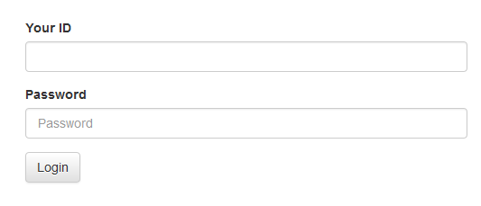

Fig: UI for login

The system will check the User Id and match the password. If any of them is wrong an error will

Occur.

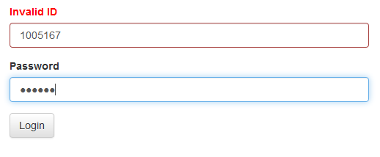

Fig: UI for invalid id

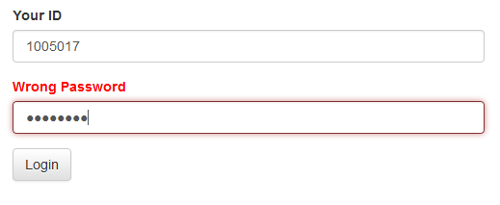

Fig: UI for wrong password

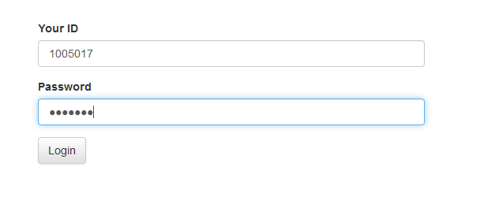

Fig: UI for valid login

If both userid and password are correct then the system will redirect the user to his/her respective pages.

There are mainly three types of user in this system.

1. Teacher

2. Student

3. Admin

The user interface is different for different user. User wise UI are described below:

Admin

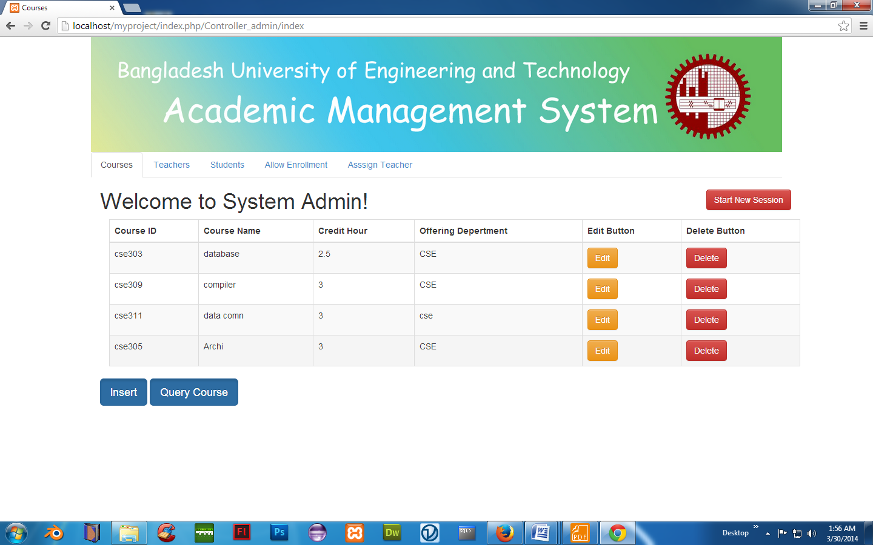

Fig: Admin Home Page

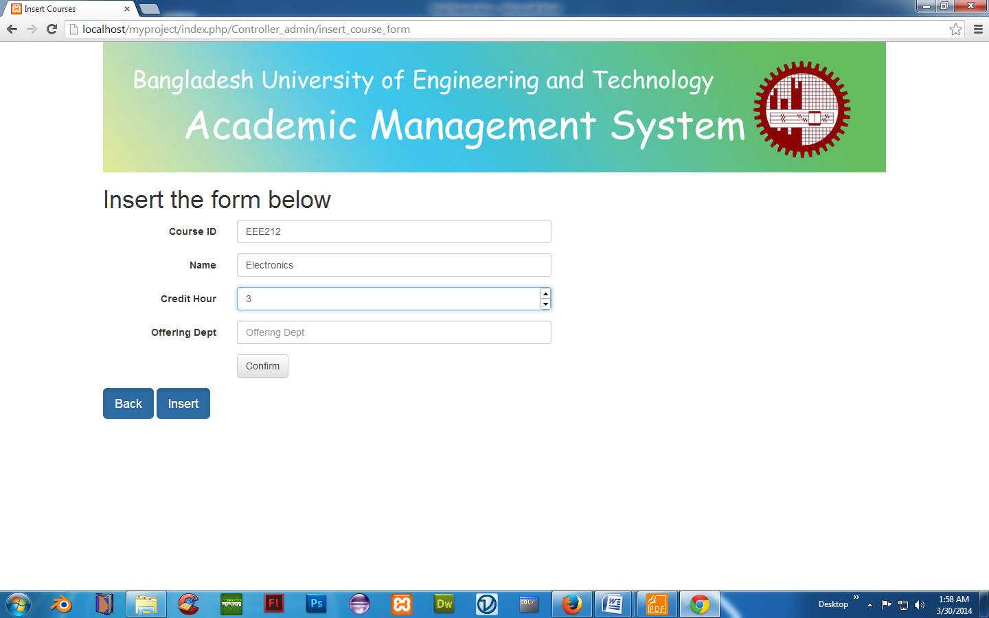  
Fig: Admin Inserting new Course

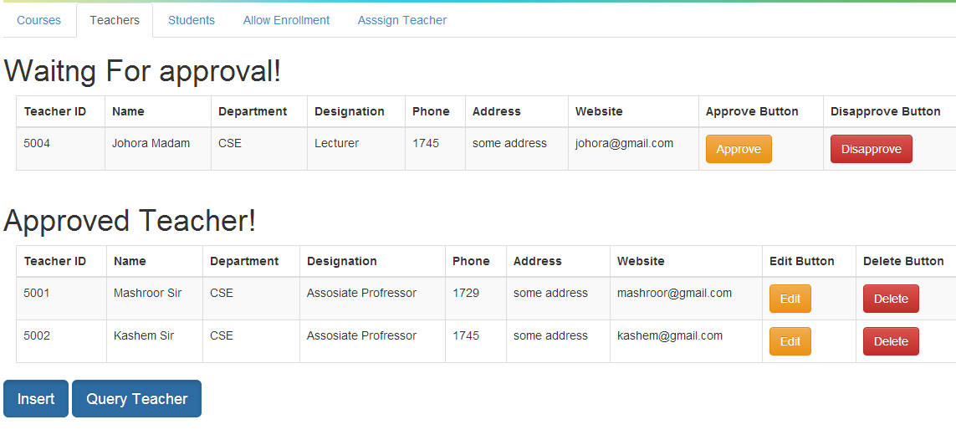

Fig: Admin Manages Teachers

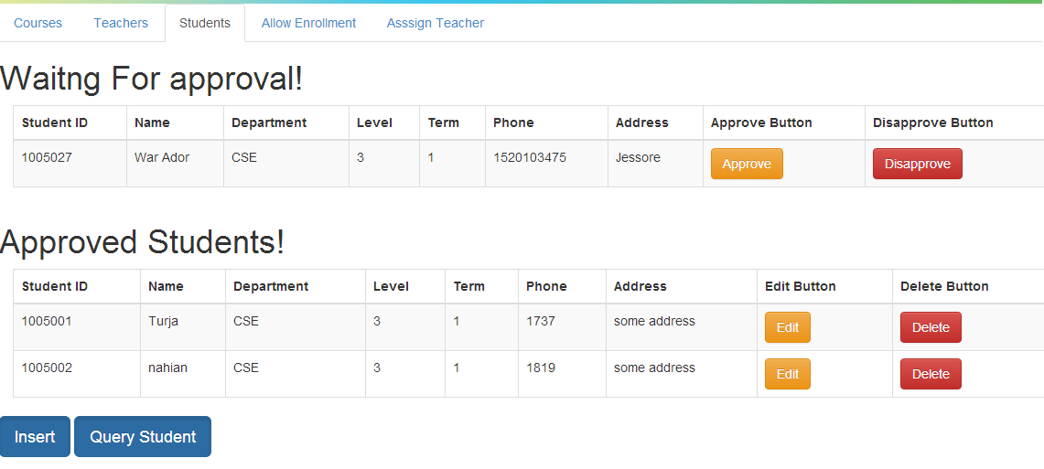

Fig: Admin Manages Students

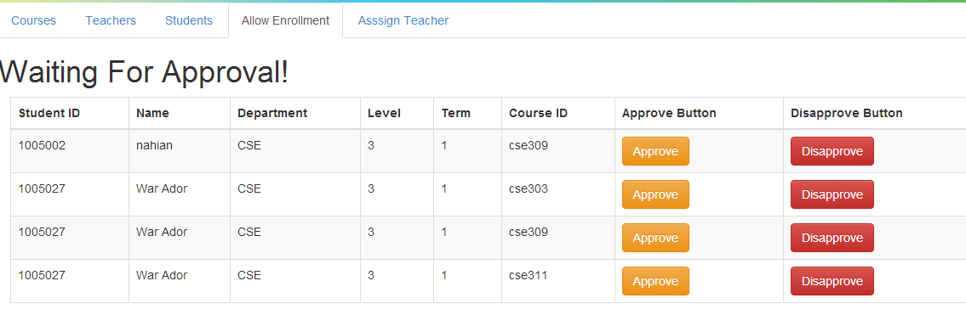

Fig: Admin Enrolls Student in courses

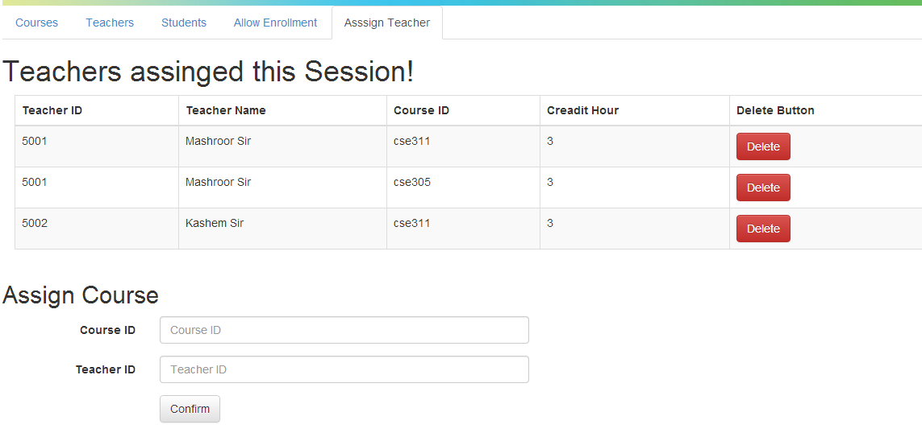

Fig: Admin Assigns Teacher

Teacher

After a successful login, a teacher’s user home page will look something like this:

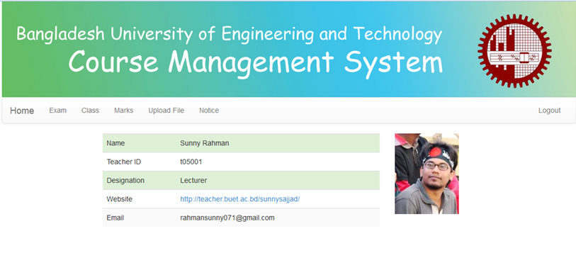Now a teacher can schedule exam, schedule extra class, give class test marks, upload files and give notice.

Exam Schedule:

When a teacher in Exam UI ,he/she can see the already scheduled exam.

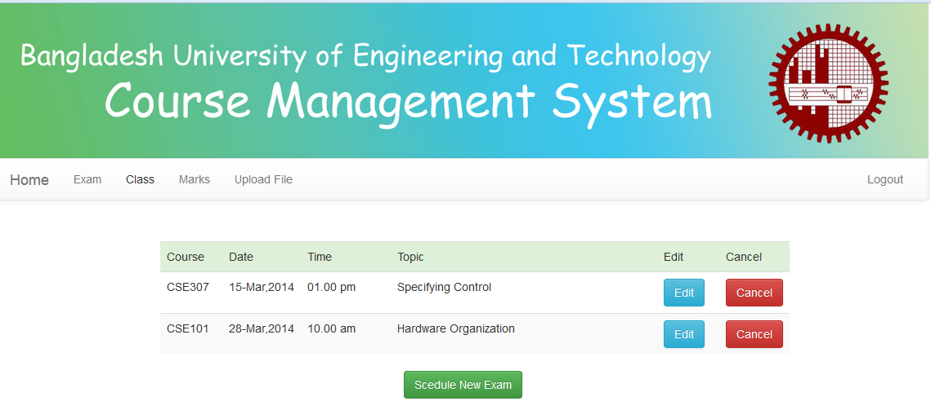

Fig: UI for Exam (teacher)

Now if a teacher wants to schedule a new exam, he/she have to click the ‘Schedule New Exam’ button.

Then the system will prompt for a form to be filled up.

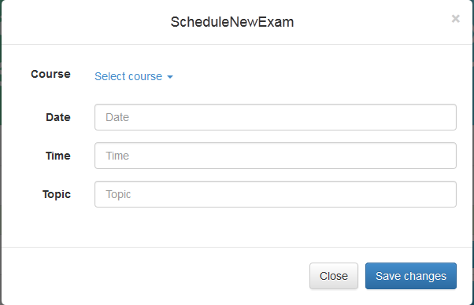

Fig: Schedule New Exam UI

The system will check every field to filled up correctly. If anything is wrong , error message will be shown.

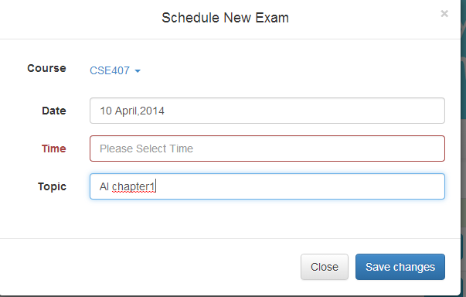

Fig: system response on empty time field

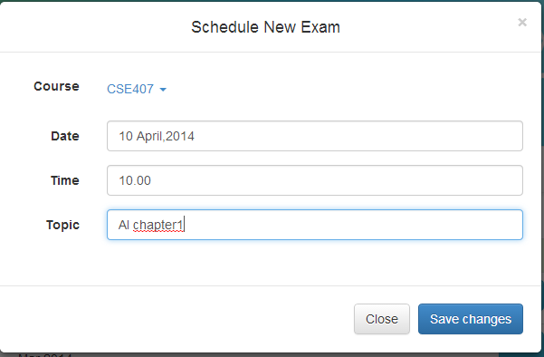

Fig: Valid Input for new exam

If all fields are filled with valid data then a confirmation will be shown and the exam will be scheduled.

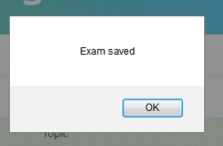

Fig: Confirmation message

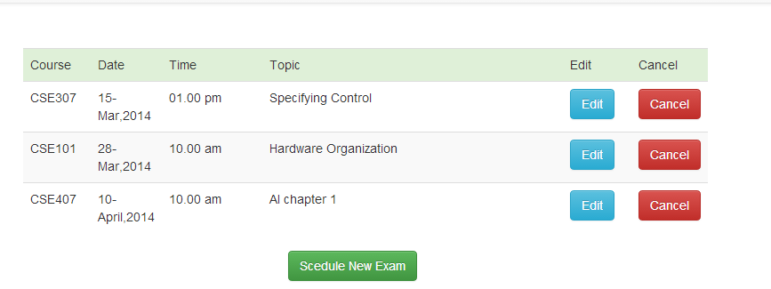

Fig: Exam saved in database

Now if a teacher wants to cancel the exam, he has to click the ‘Cancel’ button. The system will ask for

confirmation. After confirmation the exam will be deleted from database.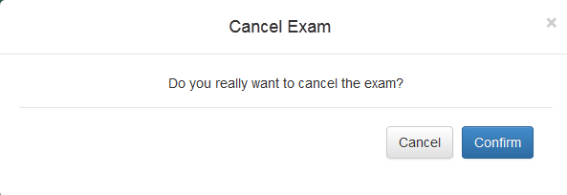

Fig: Cancel Exam UI

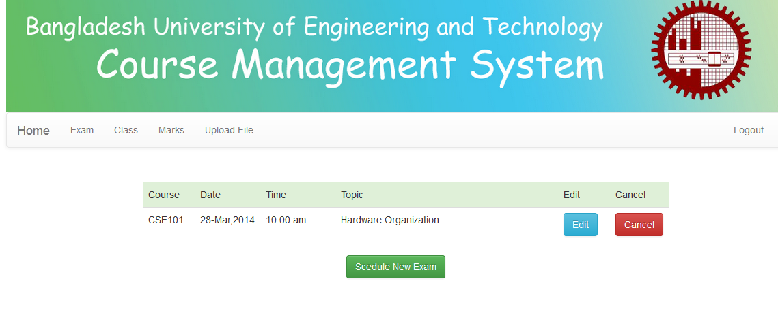

Fig: After cancelling CSE307 and CSE407

Class Schedule:

A teacher can schedule extra class on some specific topics and can also cancel the class at any time.

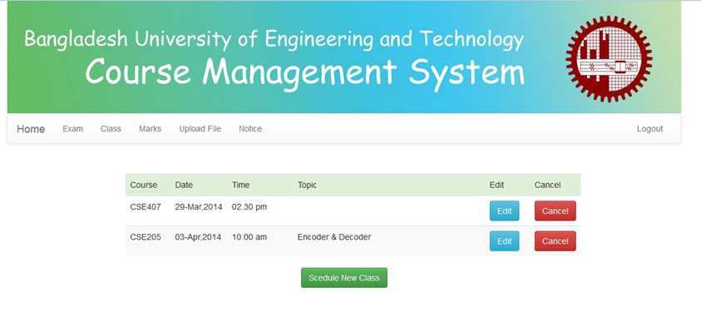

Fig: Class Schedule UI

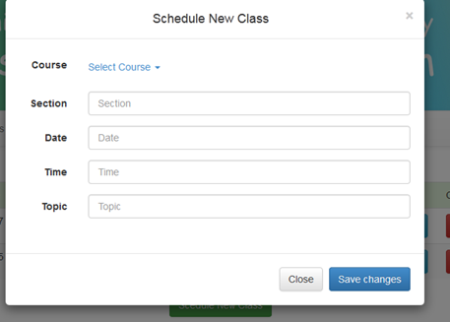

Fig: Schedule New Class UI

Now a teacher have to fill the form. Any error will be checked by the system.

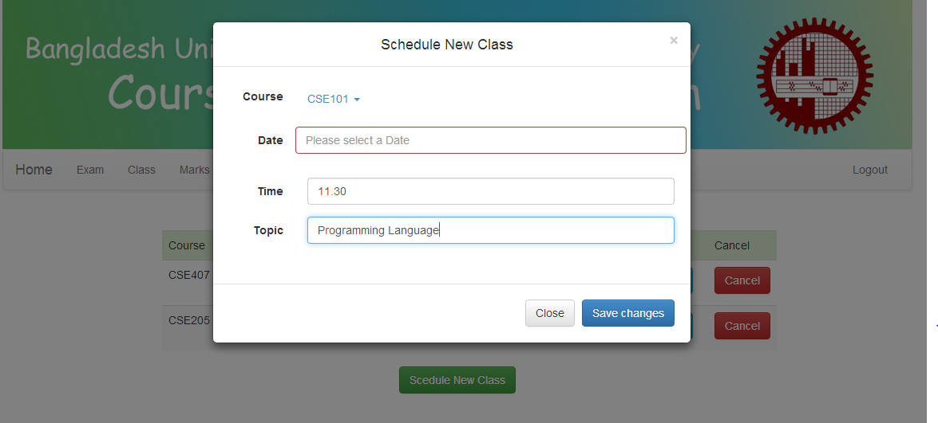

Fig: UI for incomplete form

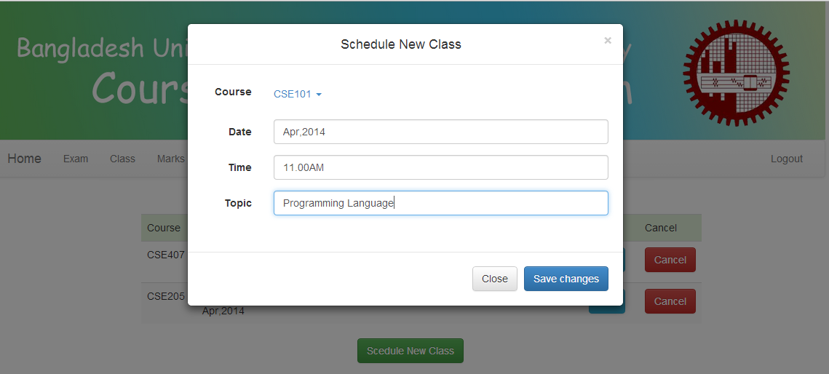

Fig: Sample Valid Input

After a valid input the system give a confirmation message and save the class into the database.

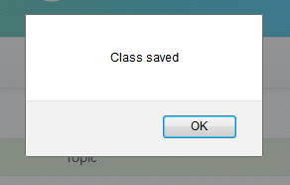

Fig: class saved confirmation

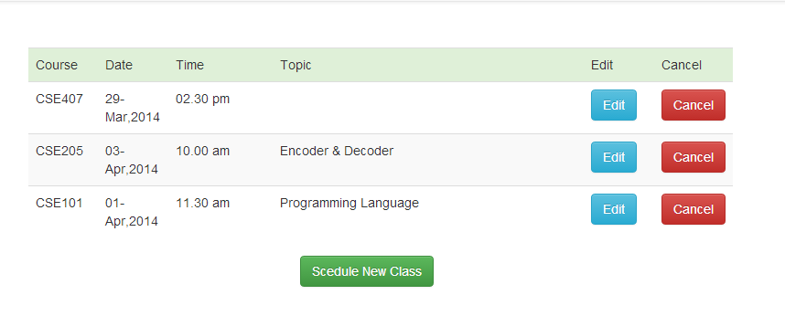

Fig: After saving class CSE101

Now a teacher can cancel a class. If a teacher click the ‘Cancel’ button then a confirmation message will pop-up and asked for confirmation. Once confirmed the class will be deleted.

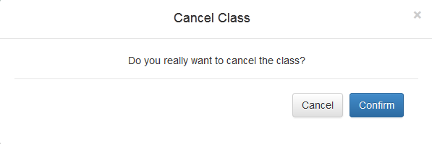

Fig: UI for class confirmation

 Fig: After cancelling class CSE205 and CSE307

Marks:

A teacher can give marks of the class test .For this he/she has to select student group and write down the marks beside the student roll. The input form will not accept anything but number.

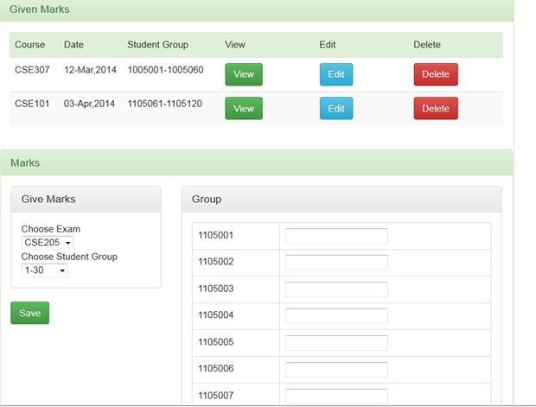

Fig: Marks UploadUI

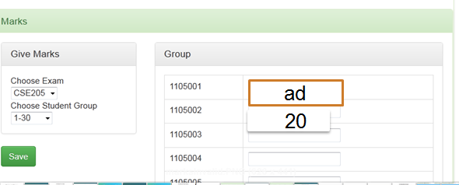

Fig: Error on Invalid Input

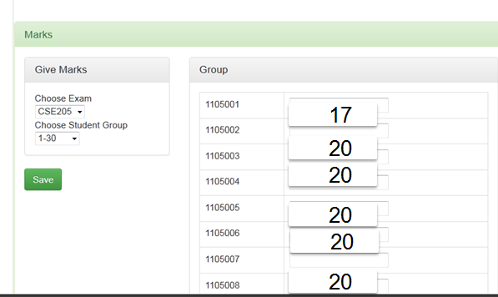

Fig: Sample valid Input marks

After a successful input the system will save the number.

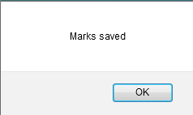

Fig: Saved marks message

Notice:

A teacher can give notice to a specific student group.

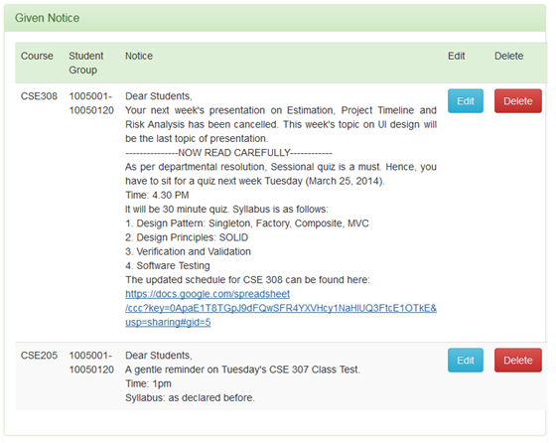

Fig: Given Notice UI

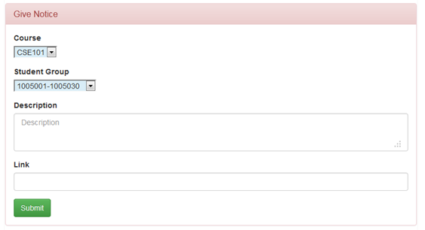

Fig: Give Notice UI

STUEDENT

After a successful login a student can see his homepage.

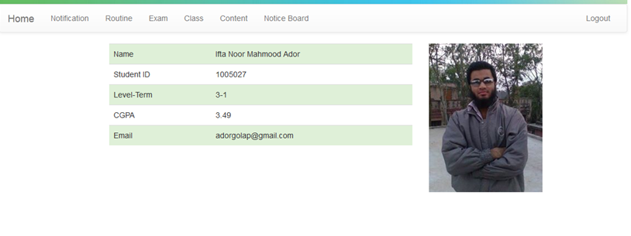

Fig: UI for student home

Notification:

If a student has notifications the system will response with it.

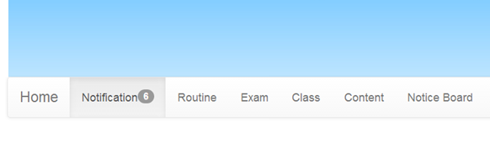

Fig: Notification (if any)

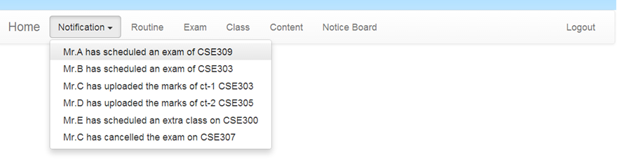

Fig: Notification UI

Routine:

A student can view his routine.

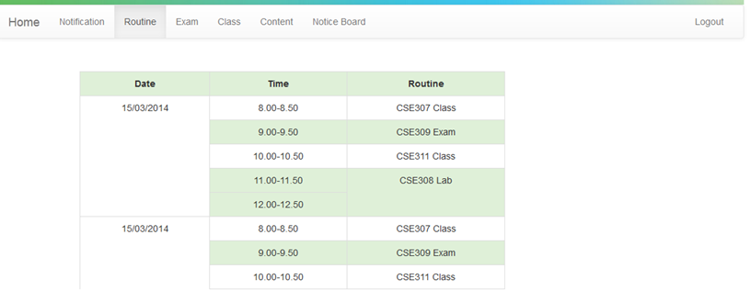

Fig: Routine UI

Exam:

A student can see both the upcoming and attended exams from this UI.

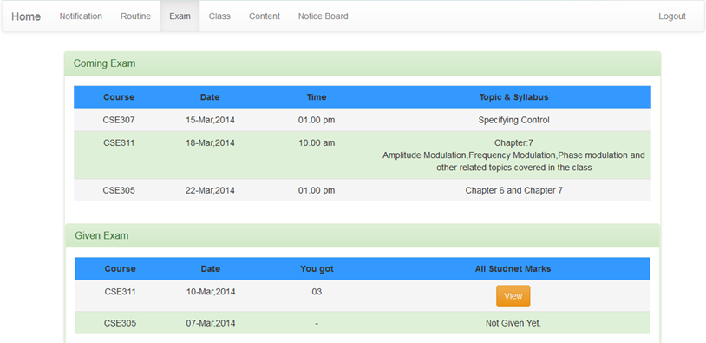

Fig: Exam Student UI

Class:

A student can see the scheduled extra class routine from this UI.

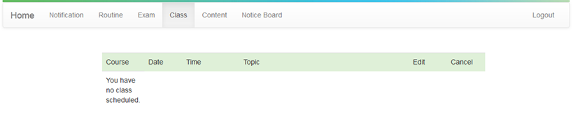

Fig: UI for Class Student

Content:

A student can download the files of related topics he has access to.

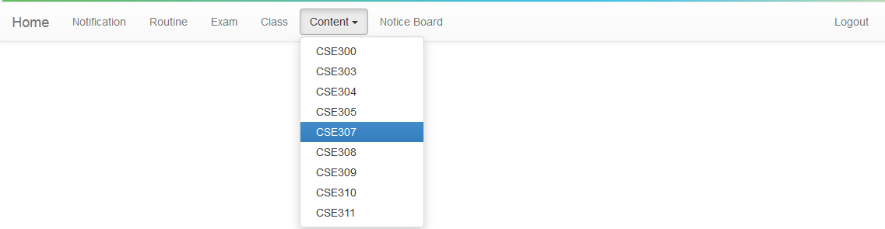

Fig: Content Course Selection

Then the system will show the student the uploaded files of the subject.

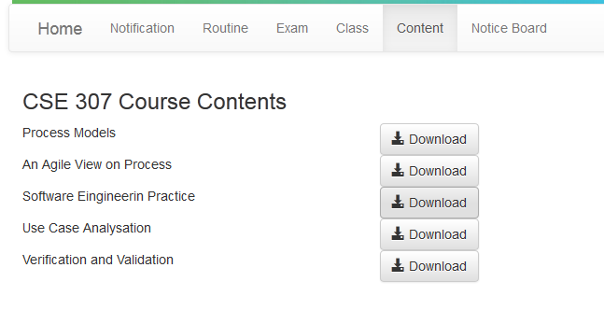

Fig: Content of CSE307

Notice:

A student can see the given notices.

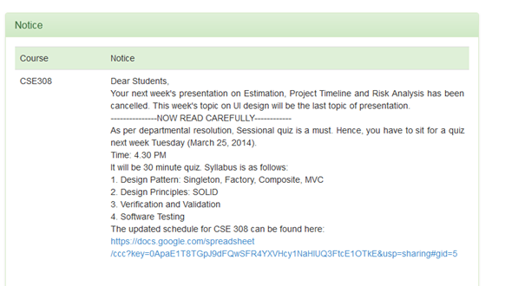

Fig: NoticeUI

Chapter 7: Project phases and Activities

7.2.3 DESIGN PHASE: .................................................................................................. Error! Bookmark not defined.

7.2.4 DEVELOPMENT PHASE: .................................................................................. Error! Bookmark not defined.

7.2.4 TESTING PHASE: ............................................................................................. Error! Bookmark not defined.

7.2.5 IMPLEMENTATION PHASE: ............................................................................ Error! Bookmark not defined.

7.2.7 MAINTENANCE PHASE

**2. Work Schedule and Project Time Analysis**

Project Time Analysis

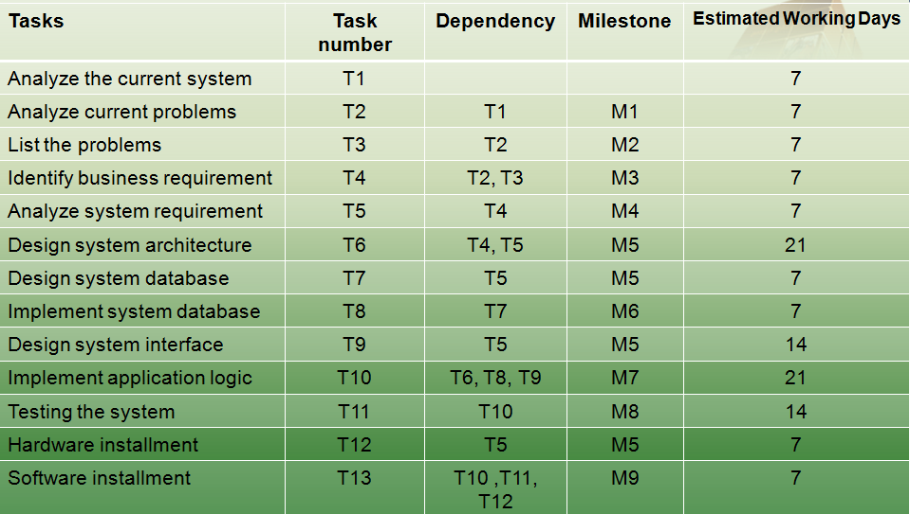

Fig: Project time analysis

Activity Time Line

Fig: Activity Timeline

PERT Chart

T13

95

95

7

T11

88

88

21

T8

46

46

7

T10

68

67

21

T6

46

43

21

T12

88

39

7

T5

7

39

39

T7

14

46

46

T9

6

32

32

7

26

32

T4

5

19

T3

19

7

14

19

T2

7

7

7

T1

Fig: PERT Chart for the System

**3. Cost Benefit Analysis**

* **Cost:**
  + Development cost:
    - Manpower: 5/6 system developer and 1/2 personnel for data entry  
      Rough estimate: 500,000/-
    - Personal Server: 400,000/-
  + Operating cost:
    - Fixed costs:
      * Periodic checking and maintenance
      * Server maintenance: 50,000/year
    - Variable costs:
      * Sudden accident: 0 – 400,000 BDT
      * Electricity Bill: 100,000 – 150,000 BDT/year
* **Bottom line:** 
  + Development cost and operating cost are relatively very low compared to a university’s annual budget.
  + BUET spends around 913.3 milion a year.  
    [Ref - <http://www.eduicon.com/News/Details/3011.html>]
* **Benefits:**

**Tangible benefit:**

* + As the project is not intended for business purposes it does not recur tangible benefits.
  + Some advertisement and sponsor offer can be obtained in future.

**Intangible benefit:**

* + Saving time of thousands of student. If the system saves 1 hour per day of each student then it will amount to a tremendous amount for all students over years of study.
  + No headache of getting used to with new platforms for each course each semester.
  + Saving labor for collecting different materials like previous years course materials etc.

**5. Risk Analysis and Management**

**Risk Identification:**

|  |  |  |  |
| --- | --- | --- | --- |
| **Risk** | **type** | **Affects** | **Description** |
| Stuff turnover | People | Project | Skilled and key stuffs may left the project before finish. |
| Authoritative disapproval | Organization | Project and product | Authority may not agree to integrate the system with BIIS. |
| Requirement change | Requirements | Project and product | Some added functions as discussion forum may be asked to add in future. If so the project schedule and quality may hamper. |
| Size underestimate | Estimation | Project and product | The overall size of the project may rise when we start implementing. |
| Management change | Organizational | Project | Change in the university management with different motivation may cancel the project. |
| Product competition | Product | Business | Other alternative system may emerge to replace our system. |

**Risk Analysis:**

After analyzing it is observed that above mentioned risks are of different probability and effect which is as follows:

|  |  |  |
| --- | --- | --- |
| **Risk** | **Probability** | **Effect** |
| Stuff turnover | Medium | tolerable |
| Authoritative disapproval | Medium | serious |
| Requirement change | High | serious |
| Size underestimate | Medium | Serious |
| Management change | Low | Catastrophic |
| Product competition | Low | Catastrophic |

**Risk planning:**Based on the risk analysis some minimization, avoidance and contingency strategy is made to deal with these risks.

|  |  |  |
| --- | --- | --- |
| **Risk** | **Strategy type** | **Strategy** |
| Stuff turnover | Minimization | Reorganize team so that there is more overlap of work and people therefore understand each other’s jobs |
| Authoritative disapproval | Avoidance | Prepare a briefing document for senior authority showing how the system is making a very important contribution to the goals of university education. |
| Requirement change | Avoidance | Alert the authority, students and teachersabout particular difficulties and potential delays involved with requirement change. Also try to persuade them current requirement is good enough to operate nicely. |
| Minimization | Increase collaboration with the users and authority to identify their entire requirement also try to predict future requirement change and start taking preparation for that. |
| Size underestimation | Minimization | Investigate tool’s capability, code efficiency. Also try to find out critical implementation points and also try to recruit experienced and highly skilled developers. |
| Management change | avoidance | Same as ‘authoritative disapproval’ |
| Product competition | Contingency | Try to figure out which possible existing system like using Facebook groups may override our proposed system. Also try find out the features and points where all other systems must lack because of inherent reasons. Reinforce efforts to compete with other systems continually until we establish ourselves in a secured level. |

**Risk Monitoring:**

Risks identified have to be monitored in a regular manner. Every twice week we need to re assess the probability and monitor the functionality of the proposed strategy. In case where probability of a risk rising we need to take necessary back-up plans. Some indicator of risks is:

1) Poor morale and poor relationship among team member may trigger staff turnover.

2) Students and teachers disinterest may result in requirements change.

3) Failure to persuade authority about amount of work need to be done to develop this system may trigger them to reduce project budget.  
In any case when a indicator of a problem shows up necessary strategy needs to be taken into account throughout the project timeline.